“2017: YEAR OF EXCELLENT MANAGEMENT”
(30 December 2016 / 30 Rabiulawwal 1438)

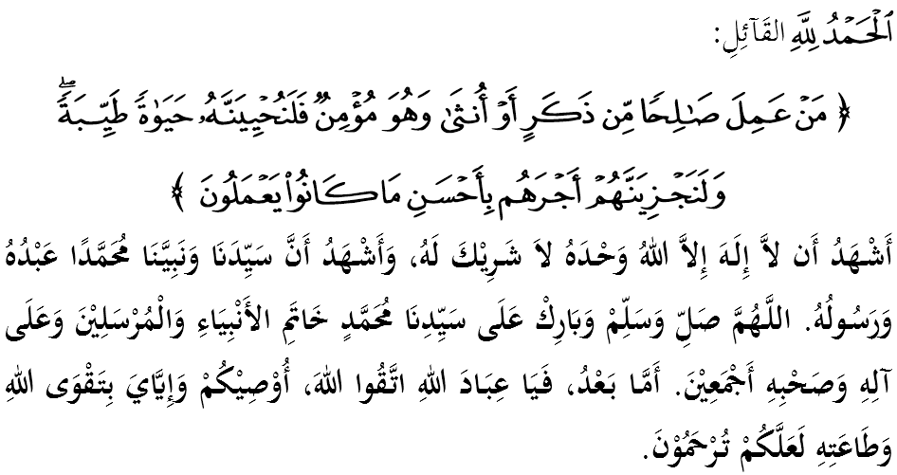

FELLOW CONGREGANTS, MAY ALLAH’S BLESSINGS BE ON US,

I call myself and my dear borthers, let us together strengthen our devotion to Allah SWT by doing all His commands and leave all His prohibitions. Hopefully we will be blessed with happiness in this world and victory in the hereafter. Mimbar would like to invite everyone to appreciate today’s sermon entitled: “2017: YEAR OF EXCELLENT MANAGEMENT”.

FELLOW MUSLIMS BLESSED BY ALLAH,
We are currently at the end of year 2016. Typically, most people are already looking forward to the year of 2017 along with the presence of various resolutions and new determination in order to soar to greater levels. Some even assume that the transition to the New Year is an important and significant event in the history of their lives, either leaving positive or negative effects on a person.
Whatever the response is, mimbar has the opinion that every new thing will come with a demand of a change or paradigm shift towards a new, more efficient and more effective management concept. Indeed, the year 2017 should be an important year to ourself, family, community and country. Allah SWT says in Surah an-Nahl verse 97:
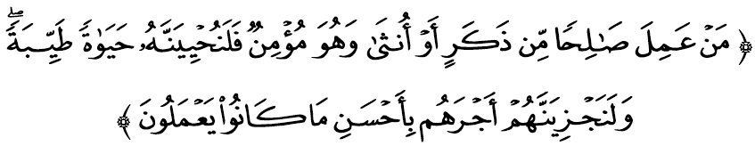

Which means: “As for anyone, whether it is a man or a woman, who does what is right, and is a believer, most certainly We shall cause him to live a good life, and We will give their reward according to the best of their actions.”

FELLOW MUSLIMS BLESSED BY ALLAH,
A good quality ummah are among the factors that mark welfare and progress of a country. As a result, the nation prospered and the people can enjoy life in comfort. Conversely, if the quality is not internalized, tragedy may occur and would results in undesirable divisions, riots, fights and wars.
What is certain, Islam has always taught the believers to always reflect on the weaknesses and the lackings as a reminder. It is worrisome that if this continues, it will be difficult for us to see our own weaknesses and tend to see the weakness and humiliation of others.
In regards to this, Imam al-Qurtubi in his tafsir, al-Jami’ li Ahkam al-Quran, explains that a good quality of life contains 5 elements, which are, (i) income (rizq) gained by good efforts and halal as well as spent in the path of Allah SWT, (ii) qanaah – being content with what they have, (iii) obtain taufiq from Allah SWT as the result of his obedience to Allah SWT, (iv) feeling saadah, which means the happiness obtained after fulfilling all the requirements of life, especially the spiritual needs, and (v) reap the rewards of the paradise as the eternal abode.

FELLOW MUSLIMS BLESSED BY ALLAH,
We offer our gratitude to Allah SWT for having made it through 2016 with secure, prosperous and sheltered from dangers, severe calamities and disasters. In addition, we are also able to maintain economic stability even in an uncertain global economy. All of these proved that good planning, a strong unity and the concept of moderation practices are able to preserve the nation’s progress.
Thus, to continue the development agenda as envisaged, let us move forward together in 2017 by providing plans and early preparation in facing many challenges that lie ahead. Instill determination and resolutions so that we can constantly improve the added value and excellence in every business.
Imam al-Ghazali explained that there are some excellent work management methods, namely (i) have a clear plan so that the objectives can be achieved, (ii) to balance the spiritual and physical activity in every practice implemented as it is a catalyst for self to work harder, (iii) to give full attention to the work done so for more clarity, (iv) appreciate the work done to achieve the best results.

FELLOW MUSLIMS BLESSED BY ALLAH,
At the same time, our attitude towards the concept of efficient management should also be emphasized for a well-managed and systematic management. This is especially on our wisdom in the matter of financial management to ensure that our economy is strong and stable over a long term. Allah SWT says in Surah al-Furqan verse 67:

Which means: “And those who (please Allah are those), when they spend are neither extravagant nor niggardly, but (on the contrary) strike a just balance between the two (extremes of extravagance and niggardliness).”

Based on this verse, it is clear that the negative attitude to spend, extravagant and miserly be the cause why financial problems are often plagued some people. To make matter worse, they failed to manage their finances wisely and prudently, such as spending extravagantly and being wasteful. Therefore, spend for things that are needed, not to follow desires. Avoid wasteful spending without planning.
In this context, Islam forbids its followers to adopt such way of life, in example, being wasteful as it is an act that squanders the blessings of Allah SWT. What worse is such action also lead to immoral things that violate the commands of Allah SWT. Prophet SAW affirmed by a hadith narrated by Imam Muslim from Mughirah bin Syu’bah r.a:
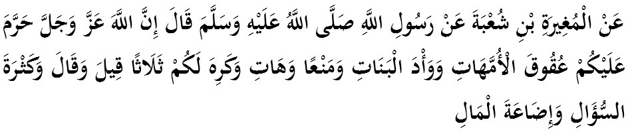

Which means: “Abu ‘Isa Al-Mughirah bin Shu’bah (May Allah be please with him) reported: The Prophet SAW said, “Allah has forbidden you: disobedience to your mothers, to withhold (what you should give), or demand what you do not deserve), and to bury your daughters alive. And Allah dislikes idle talk, to ask too many questions (for things which will be of no benefit to one), and to waste your wealth”. (Al-Bukhari and Muslim)

FELLOW MUSLIMS BLESSED BY ALLAH,
We are very grateful for being able to close the year of 2016 with a contribution of historic and resounding approval of the proposals against illegal Israeli settlements in Palestine. Mimbar believe there will be more success can be achieved in 2017 thanks to the unity and cooperation of all parties.
Thus, at this opportunity, let us work together to ensure that the management in 2017 shall be realized with commitment as well as determination. Ending the sermon today, mimbar would like to invite the congregation to appreciate the essence of the sermon as guidance in our lives, which are:

First: | Islam suggested that we always prepare and do a careful planning in any business or work to be done.
Second: | We must always be wise in managing the financial for well-being.
Third: | We must always keep and maintain the unity and harmony.
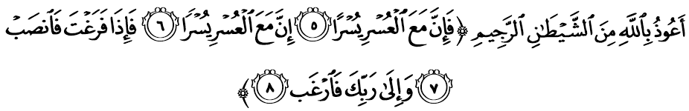

Which means: “Therefore, (be steadfast and firm in your belief). Truly, with every hardship there is ease. (It is stressed again) that with every hardship there is ease. SO when you have finished (doing a good deed) resume your toil (doing other good deeds). And to your Lord turn all attention (in asking what you desire).”

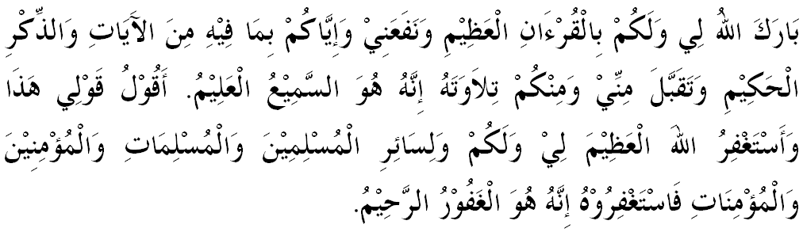

“SECOND KHUTBAH”

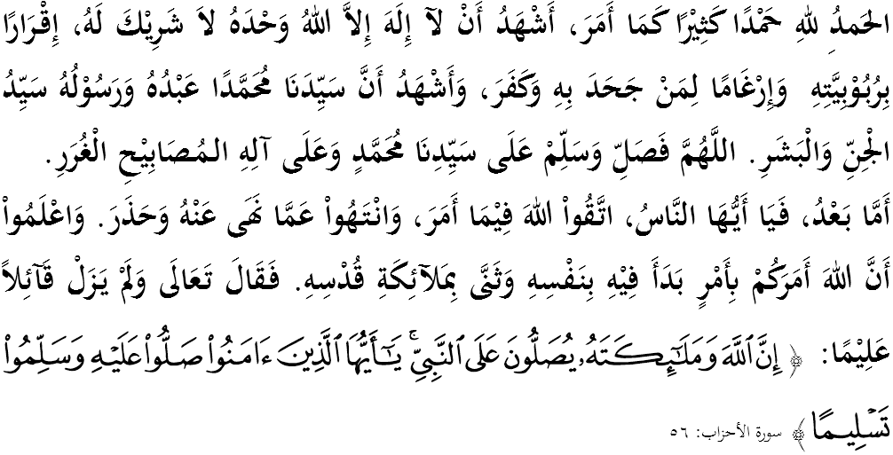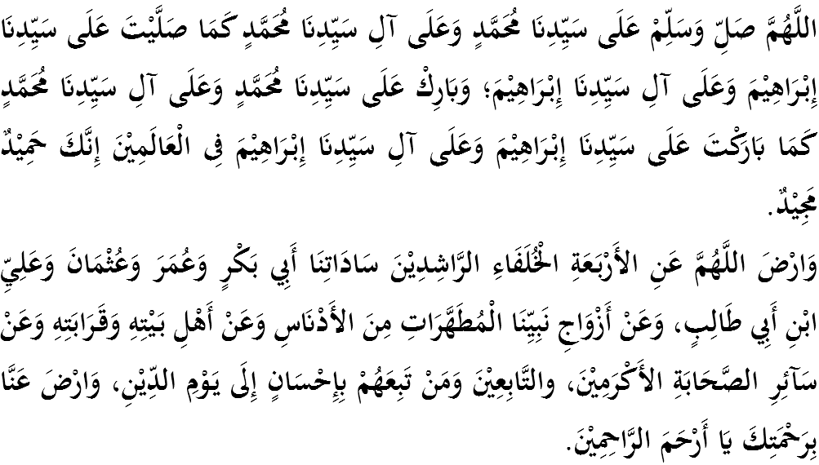
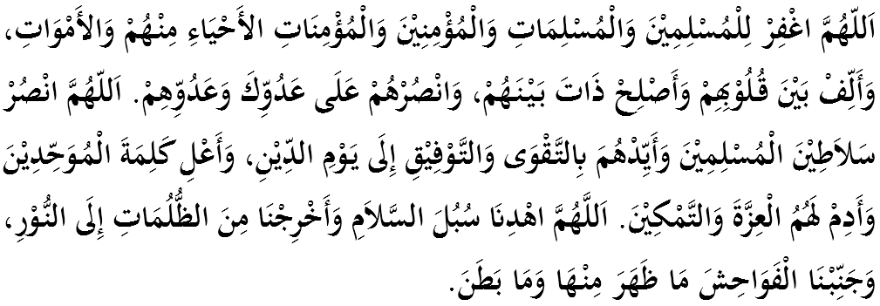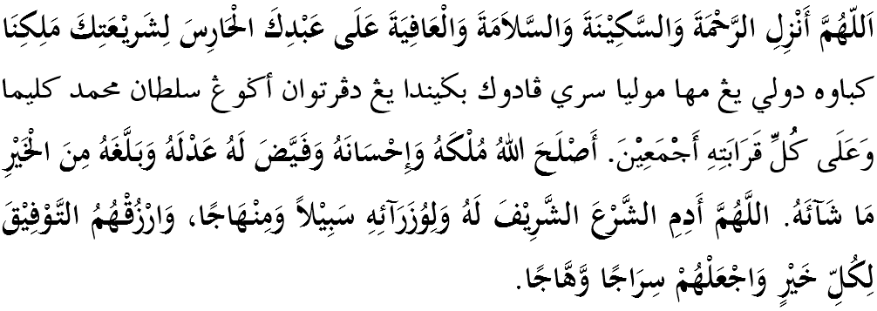
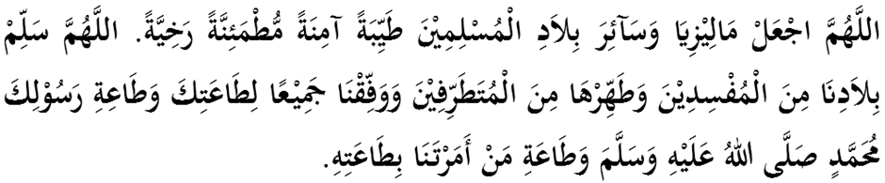

Ya Allah, we begged for Thy mercy and protection, our country and its entire people to remain in peace and prosperity. Instill a sense of affection between us. Preserve the unity among us, we wish to always live in peace, prosper and secure of all time.
