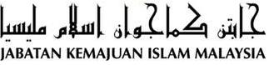

SPECIAL KHUTBAH THE WARRIOR’S DAY 2016

“HEROIC SPIRIT POWERS THE COMMUNITY”
(29th July 2016 / 24 Syawal 1437)

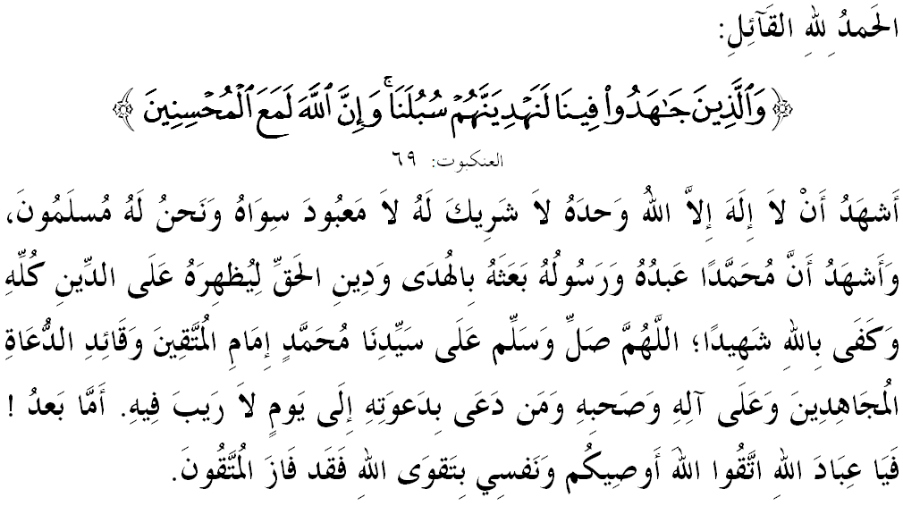

FELLOW CONGREGANTS MUSLIMIN, MAY ALLAH’S BLESSINGS BE ON US,

For the chance given to be on this blessed Friday in the month of Syawal, I would like to remind myself and fellow Friday congregation, let us together strengthen our faith to Allah SWT, vigorously implement all His commandments and leave all His prohibitions. Hopefully we get His blessing and protection in this world and the world hereafter. Mimbar today will deliver a sermon titled: ‘HEROIC SPIRIT POWERS THE COMMUNITY’.

MUSLIMIN AND MUSLIMAT,
On July 31st every year, the country will celebrate Warrior’s Day in recognition of services rendered by them to fight and sacrifice for the welfare of the people and the country. We recognize the fact that all the devotion and sacrifices made in determining state security was never forgotten by the leaders and the public.
As mimbar observes, heroism is a noble gesture that shows the soul or the nature of a warrior, soldier, fighter, brave, courageous, valor and strength of a person in defensing something he loves. Therefore, we find that the word heroism is very close to every security personnel such as Malaysian Armed Forces, Royal Malaysia Police and other security agencies. In fact, the noble view of this profession by Islam is even a high honor to them.
However, a fact that cannot be ignored is the heroic spirit is also very important to Islam. In this context, every Muslim must use this spirit to keep the akidah, ibadah, syariah, morality and the rule of Islam survived from the slander attack and the accuses by the uninformed people about Islam. For that, we have to be bold and decisive in delivering a message of truth of Islam. Allah SWT says in Surah al-Ankabut, verse 69,
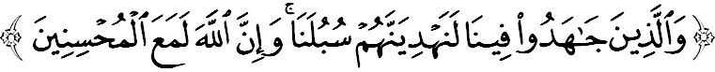
Meaning: “As for those who strive hard for Our cause in fulfilling the demands of Our religion, We will surely guide them to Our paths (through which they will gain happiness and the pleasure of Allah). And truly (the help of) Allah is with those who do good.”

MUSLIMIN AND MUSLIMAT,
As heir to the nation’s independence, we need to realize that the sacrifices of previous generations are valuable. The time taken long enough and spent quite a lot of energy. Now, we no longer need to repeat such a long history from the very beginning. The main responsibilities and our task now are to continue and maintain the heroic spirit of fall and shackled at the hands of the enemy. The call is in line with the words of Allah SWT in Surah al-Anfal verse 60,
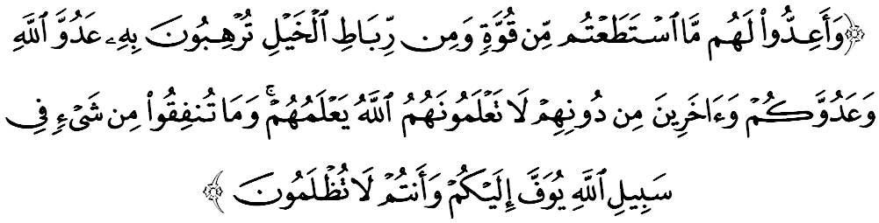Meaning: “And muster against them (the transgressing enemy) whatever force and war mounts at your disposal so that you may strike terror into the enemies of Allah and your enemy, and others besides them whom you do not know, but Allah does. And whatever you spend in the path of Allah shall be repaid to you in full, and you shall not be wronged.”
Thus, Muslims are required to be ready all the time because of the arrival of the enemy is very difficult to predict and preparation will make us more vigilant in all aspects such as improving the security, economic empowerment, education upgrading, religion upholding and social strengthening of the nation.

MUSLIMIN BLESSED BY ALLAH SWT,
If viewed from the angle of history, the spirit of heroism in Muslims has long existed. They have proven to us that among the characteristics of the main strengths lies in the strength of faith and sincerity to Allah SWT. For example, the personality of Sultan Muhammad al-Fateh and his soldiers who captured the city of Constantinople. Historically, efforts to liberate the city of Constantinople are quite difficult and take a long time since the era of the Umayyah, Abbasiyyah and Uthmaniyyah Empire in which all failed.
But with his persistence in studying and learning the experience of the Prophet Muhammad SAW in the battle with the added influence of the spirit of heroism and sacrifice of Muslim warlords before, he managed to discipline his soldiers to obey Allah SWT and the leader. This situation was described by Prophet Muhammad SAW during the war of Khandak, as narrated by Imam Ahmad from Abdullah ibn Bisyr al-Khas’amiyy RA that he said,
Meaning: “You will conquer Constantinople. Its commander is the best and its army is the best.”
This happens not only because of his prowess as a leader, but his heroic spirit is high. Surprise not that his name as the commander in war is well known in European continent. Eventually, the power of Sultan Muhammad al-Fateh is based on his personal attitude and spiritual upbringing. He was very concerned about jama’ah prayers, rawatib prayers, and tahajud prayers that were never once left before. This is why he and his soldiers were able to survive in any situation, not easily admit defeat though being offered reward in return for risking religion, race and country.
As a lesson to us all, let us contemplate and live by the words of Allah SWT in Surah at-Tawbah, verse 111,
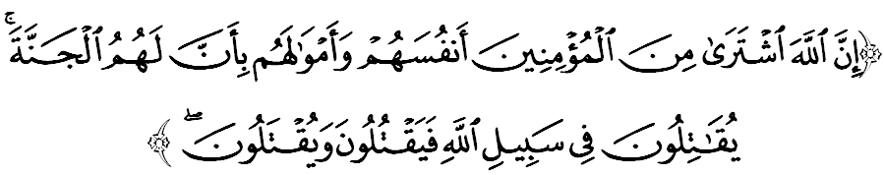
Meaning: “Allah has indeed purchased of the believers their lives and their wealth (in return) for Paradise (for) they fight for the cause of Allah, and they slay and be slain.”

MUSLIMIN AND MUSLIMAT,
As a citizen who loves the country, mimbar urge the congregation, let us cultivate the spirit of heroism and blessed by Allah SWT. May the spirit of this heroic spirit powers the community to ensure we live in peace, harmony and sovereign. On this occasion, let us pray to Allah SWT to lavish mercy to the heroes who fought and served for the sake of religion, race and country.
Ending the sermon today, mimbar would like to invite the congregation to appreciate the essence of the sermon as guidance in our lives, including:

First: | The spirit of heroism covers all aspects of life struggle to achieve the welfare of the people and our beloved country.
Second: | The sacrifices of heroes past is valuable and must be preserved in order not to fall and shackled at the hands of the enemy.
Third: | We need to always generate the power of faith and fight with sincerity for Allah SWT and loyal to leader.
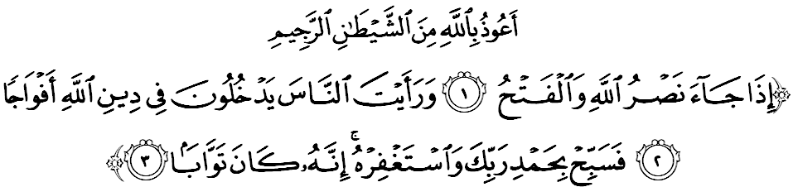
Meaning: “When Allah’s help and victory come (when you O Muhammad succeeded in conquering Makkah). And you see men embrance Allah’s religion in multitudes. Celebrate the praise of your Lord, and seek His forgiveness. For, He is ever disposed to mercy.” (Surah an-Nasr: 1-3)
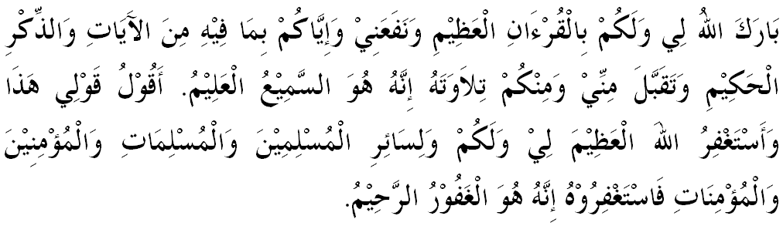

" SECOND KHUTBAH "

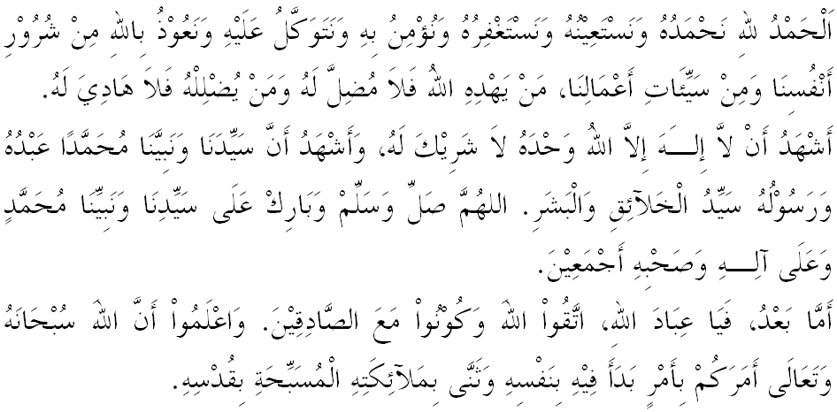
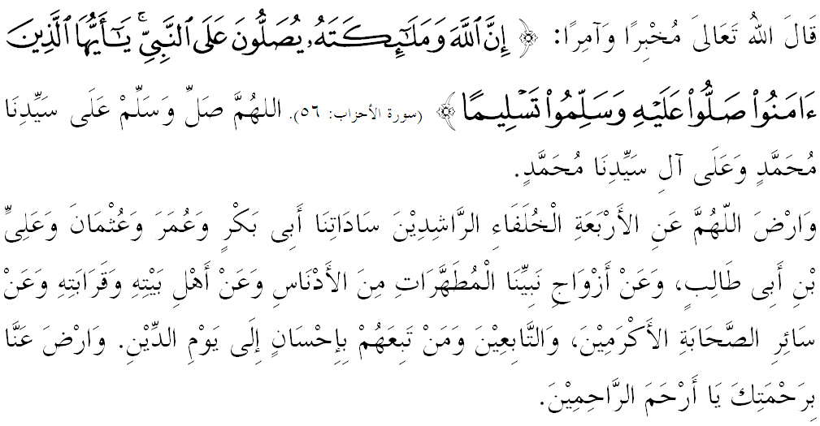

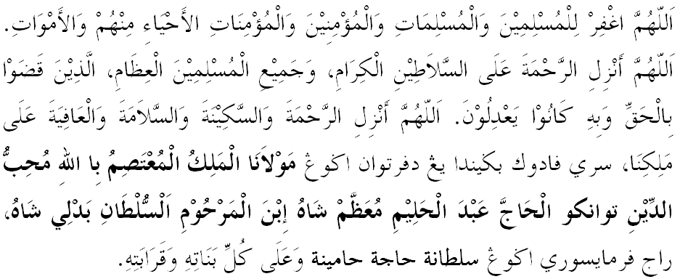
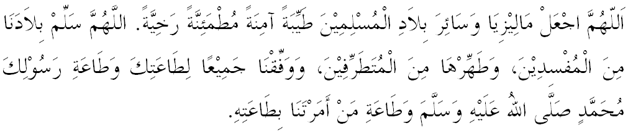

Ya Allah, we begged for mercy and Thy protection, our country and its entire people to remain in peace and prosperity. Instill a sense of affection between us. Preserve the unity among us. We wish to always live in peace, prosper and secure of all time.

