“CREDENTIAL OF THE INDEPENDENT LAND”
(26th August, 2016 / 23rd Zulkaedah, 1437)

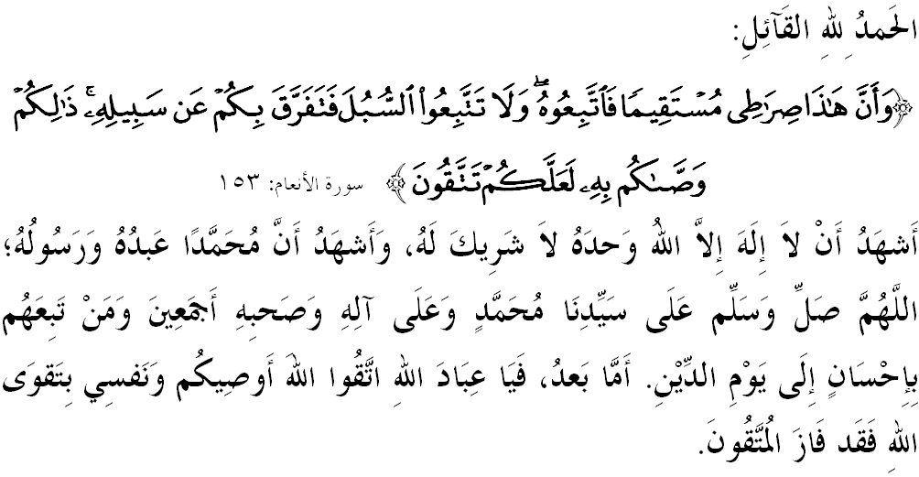

FELLOW MUSLIMS BLESSED BY ALLAH,

I would like to remind myself and call upon fellow Friday congregation, let us together strengthen our faith to Allah SWT, vigorously implement all His commandments and leave all His prohibitions. Hopefully we get His blessing and protection in this world and the world hereafter. Mimbar today will deliver a sermon titled: “CREDENTIAL OF THE INDEPENDENT LAND”.

FELLOW MUSLIMS BLESSED BY ALLAH,
Social life is a common part of human nature. This desire is heightened especially when life is hovering in the scope of a country. Thus, there are some who willing to do whatever efforts it takes, simply to achieve this harmony even though self-interest has to be put aside. However, there are times when self-control often fails due to hostilities, fights and violence occurrence. Sadly, it happens in one nation, one religion, and even in a country. Has not Allah SWT remind us to avoid this disaster by constantly conscious of Him through the teaching of Islam?
Allah says in Surah Al-‘An’am, verse 153:
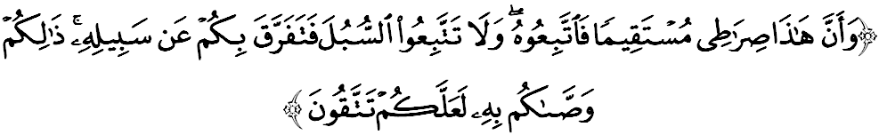 Which means: “And indeed this is My path (of the religion of Islam) leading straight; so follow it and do not follow paths (other than Islam), lest they (the other paths) lead you away from His way. Thus Allah commands you, so that you might remain conscious of Him”.

Clearly, the concept of independence for human being is not only physically free but also their spiritual and mental are free from the shackles of ignorance and they are backed with divine inspiration. An empty sense of these guidelines will lead to understanding, thinking and doctrine that they failed to understand the meaning of the Quran and Hadith in the right context hence caught up with the phenomenon of of terrorism. Due to this, breakdown, hostility and violence happens that resulted in property damage, destruction of public property, the dissolution of affection, the death of innocent people, makes children as orphans and the wife as widows. In fact, only taqwa can defend our lives to be in harmony, peace and unite closely to each other.

FELLOW MUSLIMS BLESSED BY ALLAH,
Disunity and hostility are acts or symptoms of people that are hated so much by Islam because these make Muslims weak and unable to face the challenges that exist. In addition, we will miss the opportunity to receive grace and favour from Allah SWT. Indeed, those who cause chaos and hostility are of those who are not grateful for the blessings of Allah SWT and severe punishment from Allah SWT will follow.
Eventually, Muslims lost their prowess and resulted in the repression and the threat of personal safety, property and faith. This has been going on a lot anywhere in the world where Muslims are very weak due to enmity among themselves. In Arabia, Africa, Asia, and even in our own country is not apart from the danger of enmity among the people. Lastly, Muslims lost not because of the strength of the enemy, but also because of their own weaknesses.
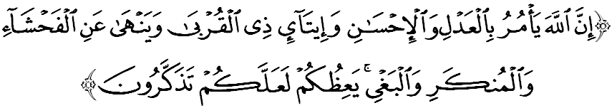
Celebrating this coming 59th Independence Day, let us get together and reflect that independence is like a credential which earned us the freedom to rule and regularly form of the national development agenda. Take lessons from the past as we build the foundation for the strength of the strategy, including spiritual and physical strength to defend the independence and also to mould the freedom accordingly to our goals. In addition to the ability of the leadership to lead the government of the country, people also need to give loyalty in one accord to ensure lasting independence. Allah says in Surah an-Nahl, verse 90:
Which means: “Allah enjoins justice, kindness and charity to one’s kindred, and forbids indecency, wickedness and oppression. He admonishes you (through His orders and His interdictions) so that you may take heed”.

FELLOW MUSLIMS BLESSED BY ALLAH,
Realizing it or not, there are in fact too many advantages and benefits that we all get along this independence. Mimbar believe if independence is truly appreciated and would always be fought for, all plannings and development programs can be set to bring progress and prosperity to the people and the country smoothly. In fact, the level of the quality and standard living of the people and the love for the country can also be enhanced.
Rasulullah SAW himself has a high value of affection to his homeland of Mecca. He once had a dialogue with the land of Mecca when forced to migrate to Medina. Ibn’ Abbas RA said:
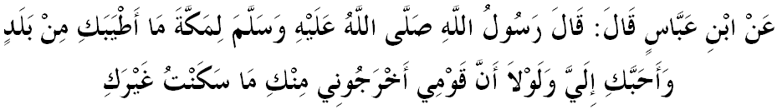Which means: “Narrated Ibn 'Abbas: that the Messenger of Allah (ﷺ) said about Makkah: "How sweet of a land you are and how dear you are to me, and if it were not that my people expelled me from you, I would not have lived in other than you." (Narrated by at-Tirmizi)

FELLOW MUSLIMS BLESSED BY ALLAH,
In realizing the dream and vision of building Malaysia as a developed nation, strong and sovereign nation, every citizen should have the awareness and the courage to take the responsibility and risk for enhancing the position and continue the struggle to improve the achievements of Muslims in all fields. Without the fighting spirit, their spirit of patriotism would be so weak that could provoke a split in society.
To make matters worse, this split will broaden the spread of extremist ideology such violence is very dangerous and a major threat to nation building. Thus, any rise of extremism committed by unscrupulous people in the name of Islamic jihad should be contained and handled as it contradicts the true Islam and causing many problems that could threaten the sovereignty of the nation state and tarnish the image of Islam. They have actually sowed the seeds of discord and undermine elements of the understanding and brotherhood between Muslims and non-Muslims. Thus, the basis for unity such as the spirit of cooperation, tolerance and understanding, loyalty to the country, fair, considerate and also positive in relationship, needs to be nurtured and practiced as a key condition for building a welfare society.

FELLOW MUSLIMS BLESSED BY ALLAH,
Alhamdulillah, all praises to Allah SWT, we are grateful having the opportunity to celebrate our INDEPENDENCE DAY in an atmosphere of peace and prosperity. To that end, mimbar urge the congregation; let us together raise the spirit of independence to preserve the sovereignty of our beloved country, Malaysia. Ending the sermon today, mimbar would like to invite the congregation to appreciate the essence of the sermon as guidance in our lives, including:

First: | Independence and sovereignty of a country is very important to preserve the life of society and a state based on the spirit of independence, strength of the bonds of brotherhood and love in order to receive the blessings of Allah SWT and also away from the elemental damage and destruction.
Second: | Independence enables human freedom to rule and regularly form the national development agenda.
Third: | A weak patriotism spirit can trigger the development of divisions of extremist ideology among the people who become the main threat to nation building.

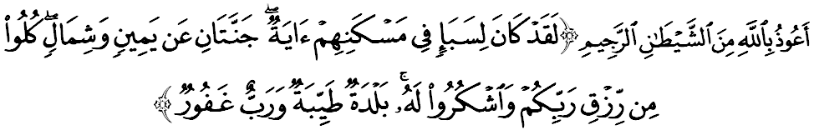

Which means: “Indeed for the people of Sheba there was a sign (of Allah’s generosity) in their homeland: two (wide and luxuriant) gardens on the right and on the left (of their dwelling place). (And it was said to them): “Eat of what your Lord has given you as sustenance and render thanks to Him. Pleasant is your land (peaceful and harmonious) and Forgiving is your Lord.” (Surah Saba’: 15)

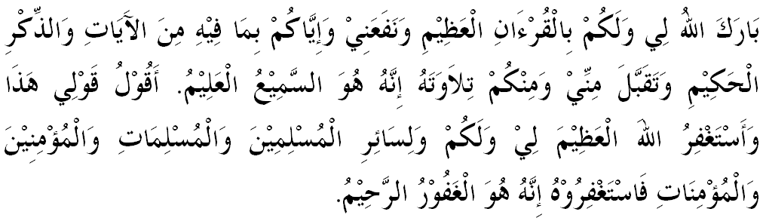

“ SECOND KHUTBAH”

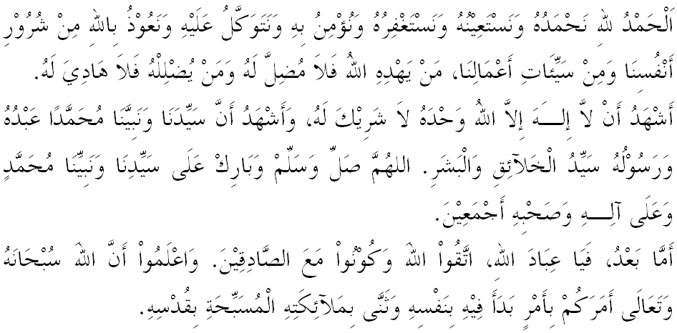
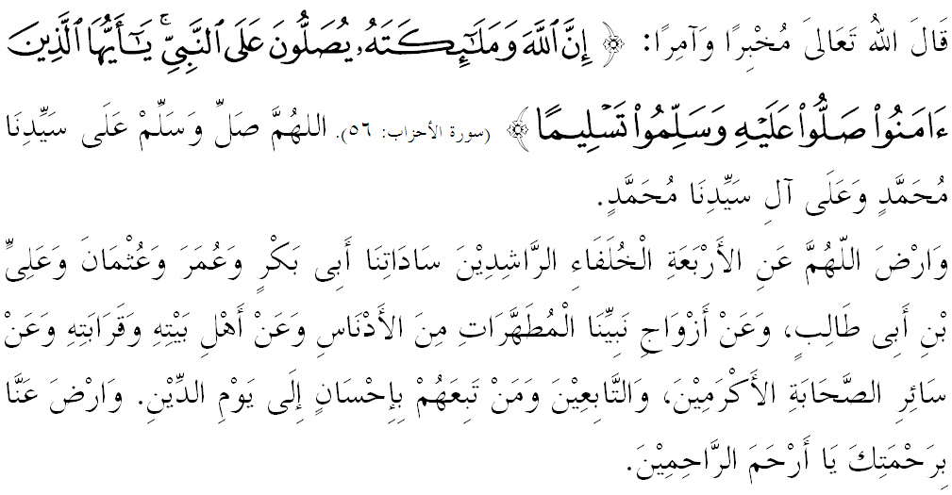

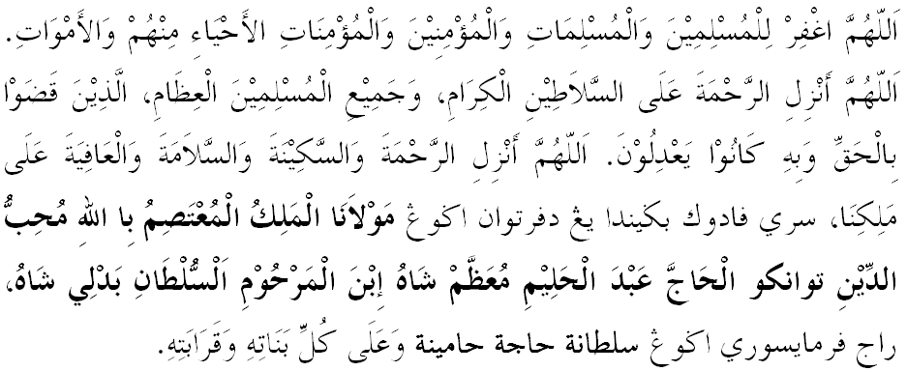
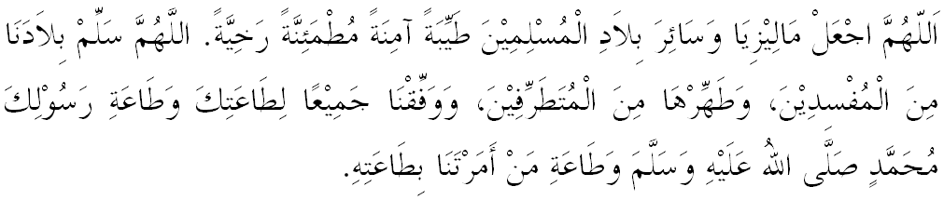

Ya Allah, we begged for mercy and Thy protection, our country and all its people to remain in peace and prosperity. Instill a sense of affection between us. Preserve the unity among us. We wish to always live in peace, prosper and secure of all time.
