DEPARTMENT OF ISLAMIC DEVELOPMENT, MALAYSIA
SPECIAL IDULFITRI SERMON (KHUTBAH):
1 SYAWAL 1436H
BOND OF LOVE COMPLEMENTS EIDULFITRI
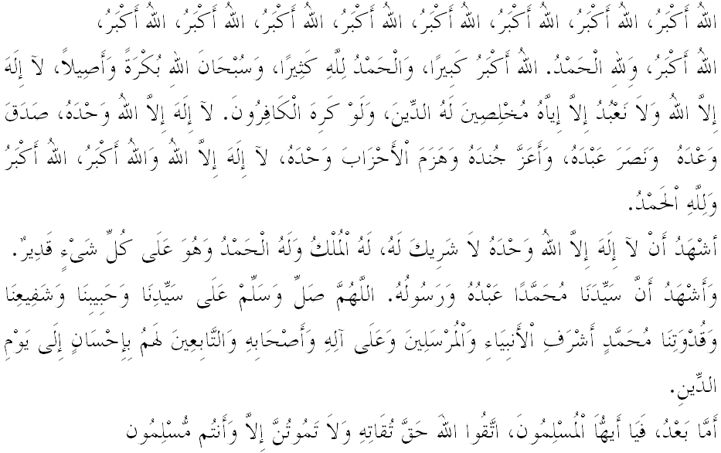
Fellow Congregants, Muslimin and Muslimat, May Allah’s Blessings be on Us,

In the morning of glory and blessedness, let us together increase our gratitude and devotion to Allah SWT with true piety. The earnest devotion that brings us to our sense of responsibility to obey all the commands of Allah and leave all His prohibitions, hopefully we will be loved Allah SWT, get His protection in the world and in the hereafter. Mimbar today will deliver a Khutbah entitled, "BOND OF LOVE COMPLEMENTS EIDULFITRI".
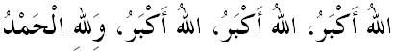
Fellow Congregants, Muslimin and Muslimat, May Allah’s Blessings be on Us,

Alhamdulillah, today, Muslims especially in our country and around the world celebrate the first of Shawwal, Eid feast. Eid arrival is greeted with Takbir and Tahmid as a sign of gratitude and victory for successfully implementing the worship during Ramadan. Worship during Ramadan by performing the obligatory and voluntarily acts of worship, like fasting, Tarawih, tadarrus, qiamullail, increase charity and so on, are expected to strengthen the bond of love between us as a complement to this Eid.
In brief, Mimbar would like to say that bond of love complements Eidulfitri means to strengthen the relationship, based on love, compassion, not hostile, and so on. The bond of love has no boundaries, no age, skin color, wealth, status and position. It should be strengthened in order to protect human relationships and love among Muslims.
After Eid prayers, we will greet our parents, relatives, neighbors, friends and acquaintances to apologize for the mistakes, and other sinful acts either knowingly or unknowingly. Allah’s decree in Surah an-Nisa' verse 36:
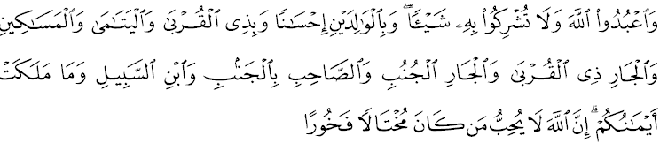Interpreted to mean: And serve Allah and ascribe no partners to Him. And show kindness to your parents and your kindred, to the orphans, and to the needy, to your near and distant neighbours, to companions, to the wayfarers, and to the slaves whom you rightfully possess. Allah does not love arrogant and boastful men;

The Prophet SAW said:
Means: "Three things are of noble character to Allah SWT; You must forgive those who have wronged you. You must help those who have decided to stop his given. You must connect with people who have decided to break the relation with you. "(Narrated by al-Khattib)

Fellow Congregants, Muslimin and Muslimat, May Allah’s Blessings be on Us,

Indeed, bond of love includes in worship to Allah SWT and is a part of the mercy of Allah SWT. Therefore, Islam always guides and points the way to the people, to ensure they are always protected. Among them, a reminder of Allah SWT that all human beings are descended from the same father and mother of one of Adam and Hawa. Allah’s decree in Surah an-Nisa ', verse 1:
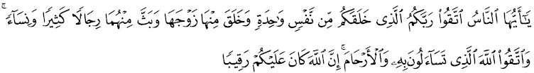Interpreted to mean: O mankind! Be conscious of your Lord Who created you from a single soul (Adam), and created from that soul its mate (his wife - Hawa), and out of the two spread abroad a multitude of men and women. And remain conscious of Allah in Whose Name you demand (your rights) from one another and honour the ties of kinship (silaturahim); for Allah is Ever Watchful over you.
As good Muslims, we are forbidden to create any animosity between us that could undermine the relationship among the ummah. Therefore, Abu Bakr al-Siddiq, the most familiar companions of the Prophet Muhammad SAW, has warned Muslims not to provoke hostility among Muslims, among his message: that those who advocate hostility are those who stand at the brink of hell just waiting for the destruction. Therefore, unite together as the merging of Muhajirin and Ansar. Similarly Saidina Uthman Affan who earnestly advised Muslims to avoid embarrassing tragedy through extreme measures that sparked the conflict. He said with the expectation that every Muslim on the other Muslims are forbidden blood, property and honor. In the same way Saidina Umar al-Khattab said: One of the fastest rewards is the good doers and connecting ties, while the fastest worse is the punishment for the evil and break up kinship.
Fellow Congregants, Muslimin and Muslimat, May Allah’s Blessings be on Us,

However, due to human weakness, whether we realize or not, bond of love of fellow Muslims today is seen started to fade. Bond of love of the community seemed united in name and form, combined with the slogan, emblem and symbol, but not in actual fact. The big question arises here, what are the things that led to this situation? Based on the Mimbar observation, this is caused by the attitude of some who are selfish, ego, emotional, obsessive, obsessed with a certain understanding and weak quality of faith in upholding the basic principles that are the pillars Muslim life.
As Muslims, we need to be aware, the wind of disunity will certainly threaten the solidarity, political stability and national development. Imagine if an act like this is allowed, this certainly led the country into chaos, economic degradation, increase crimes and cause fights in society. While disagreement was a gift and grace, but if it is not managed and prepared in the right way, according to the channel, then it certainly would invite disaster that befell on the earlier people. Indeed, things like this should be avoided to ensure the integrity and prosperity of the society and state.
Thus, Mimbar wants to remind, do not because of self-interest, we are willing to demolish the walls of unity that has long been built and destroy the existing power and dignity. Remember, Muslims who animates the meaning of love is that they are always open, kind thought and mutual respect for each other on the basis of Islamic brotherhood, irrespective of any ideology, movements and schools of thought. Therefore, always think deeply before making any action. Act with a sincere heart, calm mind and indeed common sense that every action we take gives advantages to the religion, race and nation. Believe that, the real Islamic way of life is based on relationships, siblings, helping and understanding each other as the hadith of the Prophet Muhammad SAW:
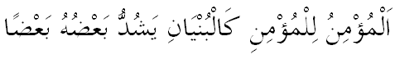
Meaning: "Comparison of brotherhood and friendship ties of a believer to another believer is like a building which partially corroborates one another." (Hadith Reported by Muslim)

Fellow Congregants, Muslimin and Muslimat, May Allah’s Blessings be on Us,

When we're happy celebrating Eidulfitri, we have to realize as there are our relatives, neighbors, friends and brothers and sisters celebrating Eidulfitri in difficult circumstances, solitary, poor, and so on. Imagine, they are the poor, neglected children, the homeless, persons with disabilities (PWDs) and those in rehabilitation centers, prisons, nursing homes, orphanages, and so on. Likewise, there are our brothers and sisters abroad, are in a difficult life, growing up in a state of war, generation after another continues to live suffering, especially our brothers and sisters in Palestine, Syria, the Muslim Rohingya refugees and the Islamic community who is being affected by disasters in other places. Hence, Mimbar urges, let us together establish the bond of love by connecting the relationship and visiting each other. Instill love and pity among us, because keep in mind that they are part of ourselves and a Muslim. Thus, we can feel the spirit of love, peace and true happiness. Prophet Muhammad SAW says;
Meaning: "Indeed, friendship is love in the family, adding wealth and longevity." (Reported by at-Tirmidhi)

In line with the blessings of Ramadan and the fulfillment of consciousness, which gave large space to foster the bond of love, Mimbar took the opportunity, let us revive and strengthen our relationships with each other. Remember all brothers and sisters, our religious practices will not be accepted by Allah SWT if we are selfish and do not respect the rights of others. Let go the ego and soften our hearts for Islam and the future of the nation. Put off all resentment and hostility because there is no point in dispute, which eventually lead to the destruction. Take a chance on this blessed day for us together to create unity among us. Hopefully in this way, our lives are always in the blessings and our country is always in harmony and peace. Next, let us reflect Allah’s decree in Surah an-Nisa, verse 149:
Interpreted to mean: Whether you do good openly or in secret, whether you forgive (the mistakes of) those who wronged you, indeed Allah is Ever Pardoning, Almighty.

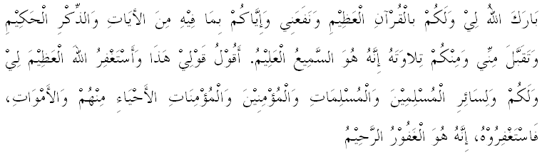
SECOND KHUTBAH IDULFITRI

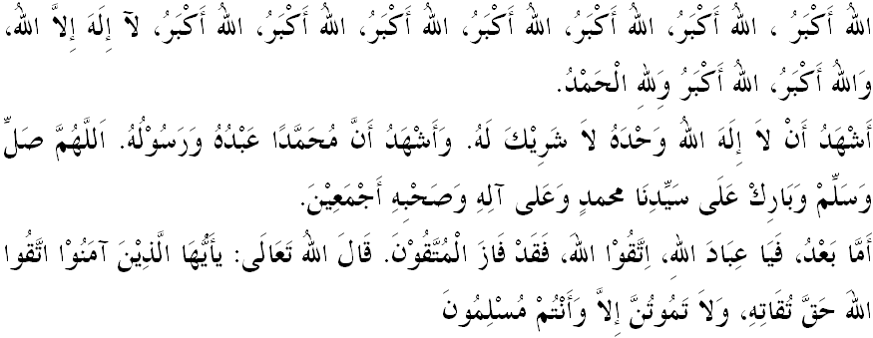
Fellow Congregants, Muslimin and Muslimat, May Allah’s Blessings be on Us,

On this blessed day, we express our gratitude for the blessings of faith and Islam bestowed by Allah SWT. Indeed Eidulfitri which is prescribed by Allah SWT is to be celebrated with gratitude and various charities that pleases Allah SWT. Mimbar hopes, celebration across the country today, filled with healthy practices, does not conflict with the teachings of Islam, does not insult Islam and pollute the blessings of Ramadan which has just passed, and the glory of the month of Shawwal. Eidulfitri means celebrate the victory for defeating desires and allowing us to go back to our identity as a devoted servant of Allah, a servant of Allah SWT who loves peace and harmony.
The scholars assert, that those who are patient and maintain good deeds after Ramadan, proved the acceptance of Allah on his deeds. Hence these devotions should be continued in the month of Shawwal by fasting for six days either consecutively or alternately. Prophet SAW said in a hadith:
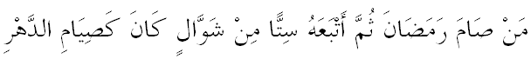
Which means: "Whoever fasts in the month of Ramadan, and then followed by fasting six days in Shawwal, it is as if he fasted for a year." (Reported by Muslim)

Mimbar also reminded once again that, Eid gives us an opportunity to build the bond of love between us. Through zakat we have paid in the month of Ramadan, has brought cheer and joy to the poor to jointly celebrate this victory. Hence, in the seconds like this, we feel so excited to be together and nourish love, mahabbah, mawaddah and erase the feeling of hatred and animosity.

Fellow Congregants, Muslimin and Muslimat, May Allah’s Blessings be on Us,

Today, let us increase salawat upon Prophet Muhammad SAW, as Islam has been presented to us through various forms of sacrifice and jihad. A sign of our love for him must be recorded in the form of implementing all Allah’s commands and leaving all His prohibitions, and consequently increase the salawat as Allah’s decree in Surah al-Ahzab verse 56:
Interpreted to mean: Truly Allah and His angles shower blessings on the Prophet (giving him honour and graces). O Believers! Bless him and greet him with a worthy salutation.

