



‘EID UL ADHA – SPECIAL KHUTBAH

“STUDY FROM HISTORY”
(01 September 2017 / 10 Zulhijjah 1438H)

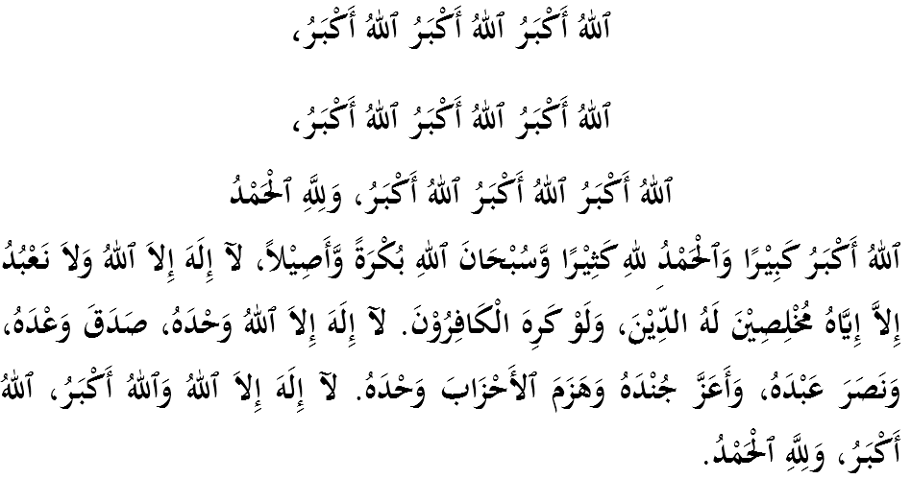
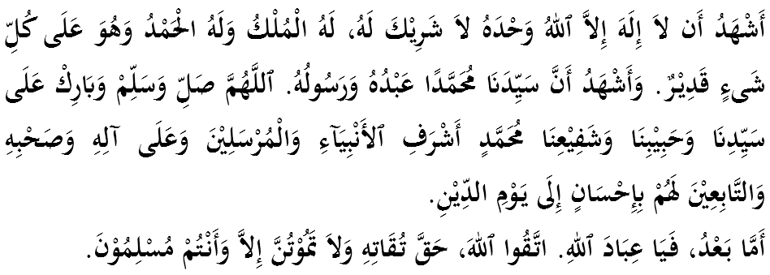

FELLOW CONGREGANTS, MUSLIMIN AND MUSLIMAT, MAY ALLAH’S BLESSINGS BE ON US,
First of all I would like to remind myself and call upon fellow congregation, let us together strengthen our faith to Allah SWT, vigorously implement all His commandments and leave all His prohibitions. Hopefully we get His blessing and protection in this world and the world hereafter. Mimbar today will deliver a sermon titled: “STUDY FROM HISTORY”.
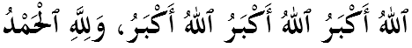
MUSLIMIN AND MUSLIMAT,
Alhamdulillah, we thank our Allah Aza wa Jalla for being given the opportunity to celebrate Eid ul Adha in a peaceful and prosperous environment. All mukmin are actually waiting for this historic day to express their obedience and taqwa towards Allah SWT. There are two great devotions that take place at this time; the Hajj in Baitullah and for those who do not perform Hajj, then it is recommended to do qurban. Indeed, these two acts require us high sacrifice and sincerity. Reminiscing the history of qurban, it begins with the revelation of Allah Azza wa Jalla to Prophet Ibrahim AS, delivered through a dream to slaughter his own son, Prophet Ismail AS. It is a very big and heavy command. This involves the long awaited son of Prophet Ibrahim AS which was finally fulfilled by Allah SWT after a continuous prayers of hope. This story is recorded in Surah al-Saaffaat, verse 100-101:

“O my Lord! Grant me a righteous son! So We gave him the good news of boy ready to suffer and for bear.”

The joy of Prophet Ibrahim AS for the child given was then tested by Allah SWT with a very big command. Within a few years afterwards, Allah SWT delivered a revelation to Prophet Ibrahim AS to slaughter his son. With strong faith and obedience owned by Prophet Ibrahim AS, the revelation was received with sincere heart and completely restored without any objection or dissatisfaction with it. Similarly, the acceptance of Prophet Ismail AS was equally the same. Prophet Ismail AS accepted the decision with open heart and sincerity without any rejection. This was mentioned further in Surah al-Saaffaat, verse 102:
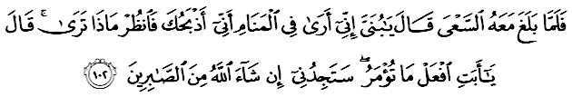 “ When the son reached (the age when he could) work, Prophet Ibrahim said: “ O the apple of my eye! Dreamt that I was sacrifing you. Tell me what you think?” His son replied: “ Father! Do as you are bidden; Allah willing you shall find me one of those who are steadfast.”

MUSLIMIN AND MUSLIMAT,
The story of qurban that occurred to Prophet Ibrahim AS has a lot of teachings and examples. Studying and taking the ibrah (lesson) from the story of Prophet Ibrahim AS and his son, Prophet Ismail AS, we know that the higher the level of a person’s faith, the greater the weight of the test that awaits him. Property, spouses, children and many other pleasures of life in this world are essentially a temporary loan. Allah SWT has the right to take back anything that has been loaned by Him without waiting for approval and our willingness. The child, for example, is one of the largest tests and amanah entrusted to a human being. Parents are willing to do everything for the well-being of their children. As the prayer recited by Prophet Ibrahim AS when asking to be given a child, according to Ibn Kathir, Prophet Ibrahim AS chanted prayer to Allah SWT so that he is given a pious, obedient, pleasure and can accompany him as he is already far apart from the family. For Prophet Ibrahim AS, a child is not only a person who will carry on his legacy, also not a person to inherit his property, but the most important thing is for the child to be able to inherit his faith and religion.
This is the principle that we should take as example in educating our children. Parents need to realize that the child is not just the person who will inherit the property, but most importantly the child is able to inherit religion and faith. We can be proud of having a wealthy, knowledgable or powerful child. But actually what we have to think deeper is their understanding of the religion. After our death, will the child still bow and prostrate to Allah Azza wa Jalla? This is the main thing that we have to ponder upon.
MUSLIMIN AND MUSLIMAT,
Qurban involved three large dimensions. The first dimension is in terms of aqidah. The sacrifice made by Prophet Ibrahim AS can liberate him from servitude to the world – and in this situation, his beloved son, Prophet Ismail AS, goes towards the slavery to Allah SWT solely. Prophet Ibrahim AS shows his faith, submission and obedience only to Allah Azza wa Jalla.
Secondly, spiritual dimension. The sacrifice is the medium to prove our faith towards Allah SWT. The word qurban literally means ‘near’, and it is meant as a way to draw us closer to Allah SWT by approaching the human being through sacrification.
Imam Ghazali asserted that slaughtering sacrificial animals is a symbol of slaughter or removal of the inherent attributes of humanity, such as gluttony, greediness and many others. By sacrificing, hopefully all human beings can throw away the traits of goodness that can bring disaster and tragedy.
While the third is social dimension. Every worship that Allah SWT implores contains maslahah and benefits to human life including qurban, zakat, sadaqah, prayer, Hajj, fasting, aqiqah. All of these ibadah contain social values that are mutual to each other. Qurban creates inner consciousness to always care about the condition of others. It can also bridge the gap between the rich and the poor through gotong-royong and the distribution of the meat. Therefore, the goal of qurban is not only to achieve the benefit of the hereafter but also to the benefit of the world because every law of syara’ is contained in the purpose of syari’at (maqasid al syariah), that is the achievement of the world and the hereafter.

MUSLIMIN AND MUSLIMAT,
Qurban is teaching us the meaning of love and obedience to Allah SWT. As a servant to Allah al-Khaliq, we should place our love for Allah SWT as high as possible, above the love towards our spouses, children, wealth and so forth. Exemplify the love and obedience of Prophet Ibrahim AS and Prophet Ismail AS to Allah SWT when commanded to abandon his son and wife, Saidatina Hajar in a barren dessert, as well as being commanded to slaughter his son and a series of heavy orders. Similarly with the love of the Rasulullah SAW to Allah SWT and his adherence in receiving commands from Allah SWT. Indeed, there are various forms of exemplary things in the Messengers that our humanity should emulate.
The love towards Allah SWT also needs to be followed by the love towards Rasulullah SAW. Allah SWT says in Surah Ali Imran, verse 31,
“Say (O Muhammad): “If you love Allah, follow me, Allah will love you and forgive your sins. And (remember) that Allah is Most Forgiving, Most Merciful”
Prophet Ibrahim AS has also shown us that the essence of the leadership is trust, struggle and sacrifice. These aspects are now being forgotten. Many people consider leadership and position as opportunities and powers. They forgot the mandatory mandate which is to serve the people who are being led. The concept of sacrifice in service and carrying out responsibilities has begun to fade today. Not many are willing to volunteer for the society. All the services are needed to be paid even the services are actually made to assist the community. Those services are now becoming profit-based businesses.

MUSLIMIN AND MUSLIMAT,
Ending the sermon today, let us internalize the essence of the sermon that has been delivered as guidances in our daily life:
First: | Make Prophet Ibrahim AS and Saidatina Hajar as role models in the sacrification of what we love the most; Prophet Ismail AS whom they missed for many years of his presence, sacrificed for the sake of love and obedience towards Allah SWT.
Second: | Parents are obliged to provide the best religious and social education to their children. It is a must to teach them to know and love Allah Azza wa Jalla.
Third: | Qurban needs to be embraced and not merely as traditions of heredity because it contains many benefits and wisdoms, either expressed or implied.

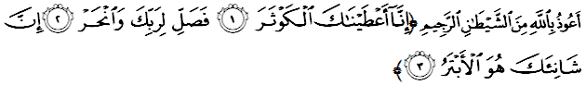 “Indeed, We have granted you(O Muhammad) abundance (in this world and the Hereafter). Therefore, pray to your Lord and sacrifice to Him only (as a sign of gratefulness). For he who hates you, shall be deprived (from getting what he desires)” (Surah al-Kauthar:103)

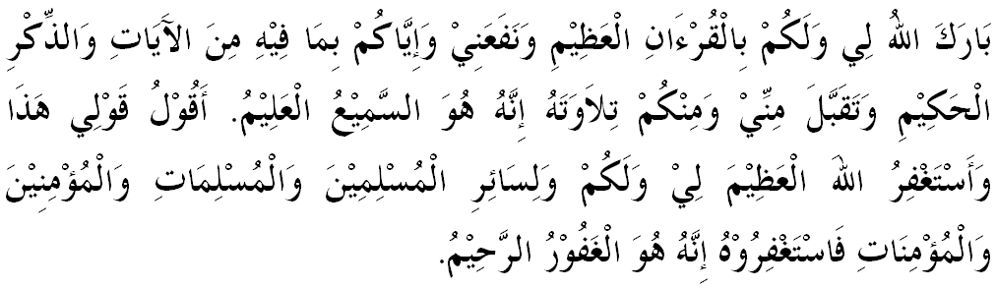
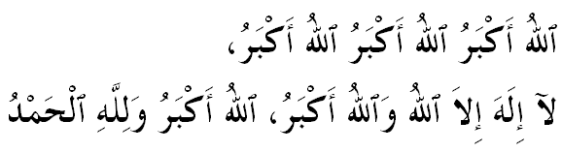



KHUTBAH KEDUA
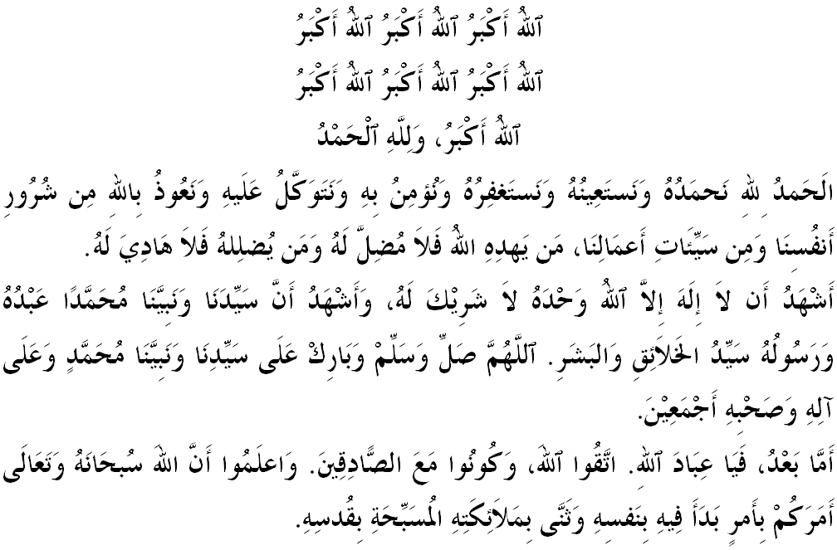
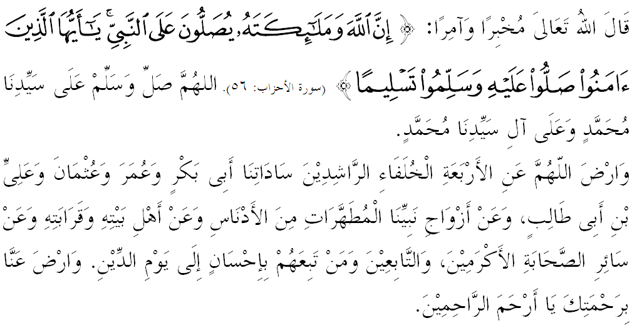
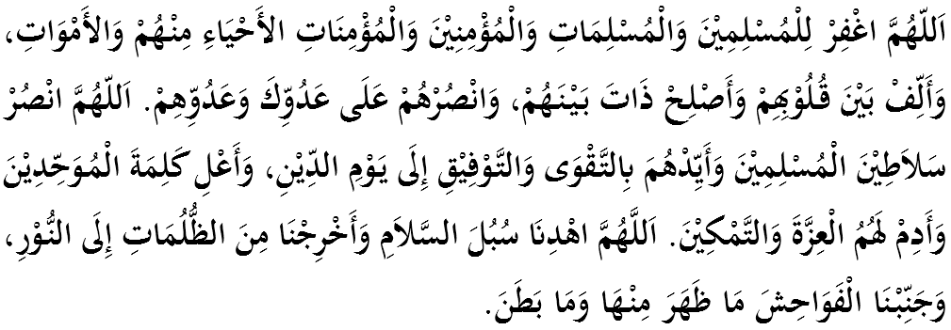
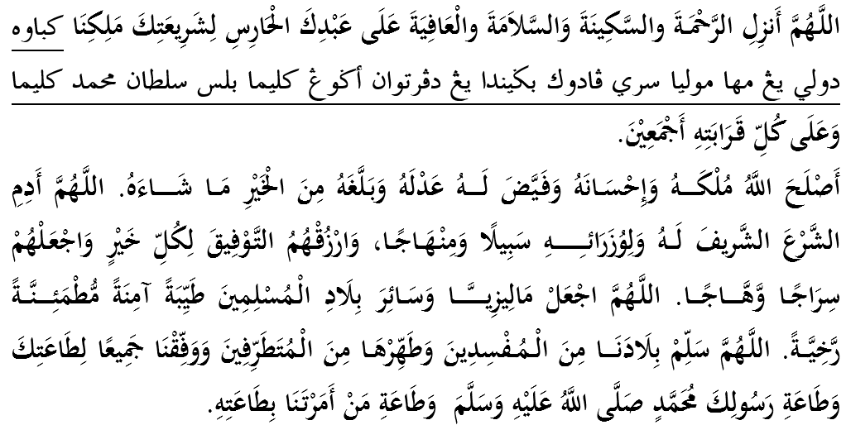
اَللّهُمَّ اجْعَلْ مَالِيْزِيَا وَسَائِرَ بِلاَدِ الْمُسْلِمِيْنَ طَيِّبَةً آمِنَةً مُطْمَئِنَّةً رَخِيَّةً. اللَّهُمَّ سَلِّمْ بِلاَدَنَا مِنَ المُفسِدِينَ وَطَهِّرهَا مِنَ المُتَطَرِّفِينَ وَوَفِّقنَا جَمِيعًا لِطَاعَتِكَ وَطَاعَةِ رَسُولِكَ مُحَمَّدٍ صَلَّى اللهُ عَلَيهِ وَسَلَّمَ وَطَاعَةِ مَن أَمَرتَنَا بِطَاعَتِهِ.
Ya Allah, we begged for Thy mercy and protection, our country and its entire people to remain in peace and prosperity. Instill a sense of affection between us. Preserve the unity among us, we wish to always live in peace, prosper and secure of all time.
