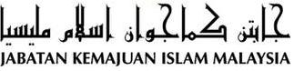

“JIHAD IN KNOWLEDGE WILL ADVANCE THE COUNTRY”
(28 October 2016 / 27 Muharram 1438)

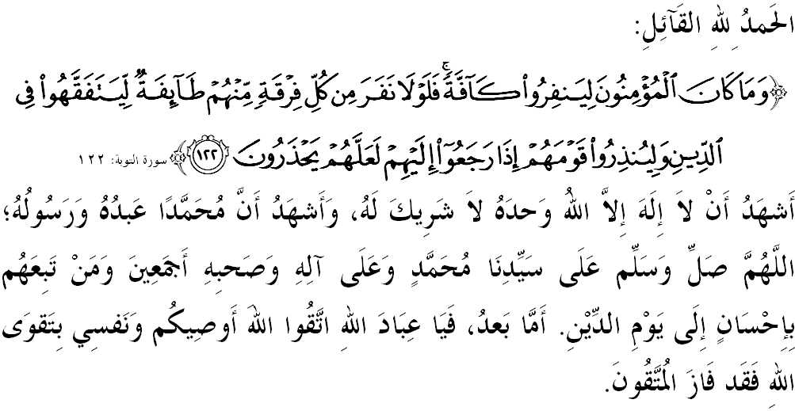
FELLOW MUSLIMS, MAY ALLAH’S BLESSING BE ON US,

I call myself and my dear brothers, let us together strengthen our devotion to Allah SWT by doing all His commands and leave all His prohibitions. Hopefully we will be blessed with happiness in this world and victory in the hereafter. Mimbar would like to invite everyone to appreciate today’s sermon entitled: “JIHAD IN KNOWLEDGE WILL ADVANCE THE COUNTRY”.

FELLOW MUSLIMS BLESSED BY ALLAH,
Knowledge is the foundation for success. Without success, individuals, communities, nations and even countries will be underdeveloped and will miss out on all important areas and fields. Thus Islam has required all Muslims to seek knowledge to achieve success in this world and in the hereafter. In the context of the country’s needs today, we are in dire need of human capital as someone who not only have knowledge in various fields, but also includes the personal aspect and high morality that must present in each individual soul. Allah SWT says in Surah al-Mujadalah, verse 11:
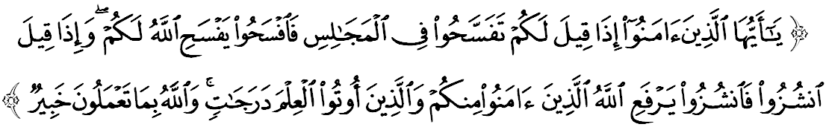Meaning: “O believers! Make room (for other people) in your assemblies when you are bidden to do so: Allah will make room for you (in everything). And rise up when you are told to rise. Allah will raise to high ranks those who have faith and those who have been granted knowledge among you. And Allah is well-acquainted with all that you do.”

Therefore, to meet the aspirations of this verse, Budget 2017 reflects the determination of the Federal Government to promote the teachings of Islam with an allocation of RM30 million for the tahfiz schools, thereby producing balanced knowledgable generation of the world and hereafter. This step is in line with the realization of the Tahfiz National Education Policy to meet the demands of the next generation of ‘Ulul Albab.

This major contribution will clarify the direction of the country towards ensuring the educational institutions of tahfiz al-Quran to flourish. Thus helping to encourage the desire to produce more huffaz through a more comprehensive education system. Hopefully, this budget will be the driving force that can lift the dignity of Islam in this country and also internationally as well as preserving the purity of the religion while rejecting the accusations and slanders by the extremists against Islam.

FELLOW MUSLIMS BLESSED BY ALLAH,
Islam as the guide to life, calling us to build a life in this world with knowledge values, faith and piety towards Allah SWT. To compile this agenda, the Islamic education should be adjusted to make it more orderly and systematic, and can continue to expand the glory of Islam in the right track.
Since our Independence Day until now, many efforts have been undertaken by the government in providing the infrastructure of religion’s knowledge from pre-school up to higher education institutions. Through the given allocation, the desire to coordinate tahfiz education in order to achieve a better and condusive learning environment throughout the country will be achieved. Also, not to be forgotten, the registered pondok education system also received the same plea for the development and maintenance of its facilities with an allocation of RM50 million.
In addition, supports are also given to the Teachers of Fardhu Ain Religious Class (KAFA), Imam, Bilal and Siak of the mosque and surau which has been educating our children since their childhood until they are able to recognize and read the Quran. The children determines the future of this country, they should be bent from the shoot, to enable them to integrate the civilization and the knowledge of revelation well. These are clear evidencse of how the leaders and administrators of this country are concerned with the principles of Islam, in which they are practiced with the principals of Wasatiyyah based on Ahlus Sunnah wal Jamaah as the source of the strength to the community and the country.

FELLOW MUSLIMS BLESSED BY ALLAH,
At the same time, we need to use this knowledge as a catalyst for good and systematic financial management. In the current economic state, there are people who get stressed and are in a state of suffering from the financial problems. Indeed, the financial pain will affect not only personal reputation, but also affect emotional distress including health, mental and emotional stability. Therefore, mimbar reminds us to spend prudently and ensure all essential precedence over the desires and also to save for the future.
Mimbar believes, with appropriate knowledge, we can control the behavior of generating a variety of issues that are often become the concerns to the Muslim community. What is more saddening is when the spread of the issue caused anxiety and confusion among the Muslim community especially when it is being viraled by unscrupulous people with unknown facts as halal issue and so on.
Was not Islam has given the guidelines that every thing that is in doubt shall be referred directly to an expert. Allah SWT says in Surah an-Nahl verse 43:
Maksudnya: “And We have not sent any before you (Q Muhammad) but men to whom We revealed (the Scriptures). Thus, ask, O you (polytheists), those who have good knowledge of religion if you do not know.”

Thus, Dr. Yusof Al Qardhawi, in his book Halal and Haram declares that Muslim who equates the people who banned the halal and otherwise, is the same as associating (syirik) Allah SWT. Therefore, as consumers who are knowledgable and wise, we need to get confirmation from the jurisdiction in order not to aggravate the situation.

FELLOW MUSLIMS BLESSED BY ALLAH,
Ending the sermon today, mimbar would like to invite the congregation to appreciate the essence of the sermon as guidance in our lives, which are:

First: | Knowledge is the bridges of success to individual, society, nation and ountry in order to achieve success in this world and in the hereafter.
Second: | Smart and wise consumers always practice Tabayyun to get confirmation from the jurisdiction in order not to aggravate the situation.
Third: | The practice of Wasatiyyah principals based on Ahlus Sunnah wal Jamaah ideology will create the power of ummah and the country.
Maksudnya: “O believers! If a wicked person brings you a piece of news, inquire first into its truth, lest you should wrong others unwittingly and repent of what you have done.” (Surah al-Hujurat verse 6)

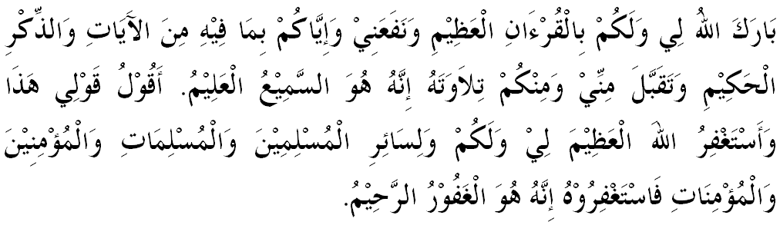

“ SECOND KHUTBAH”

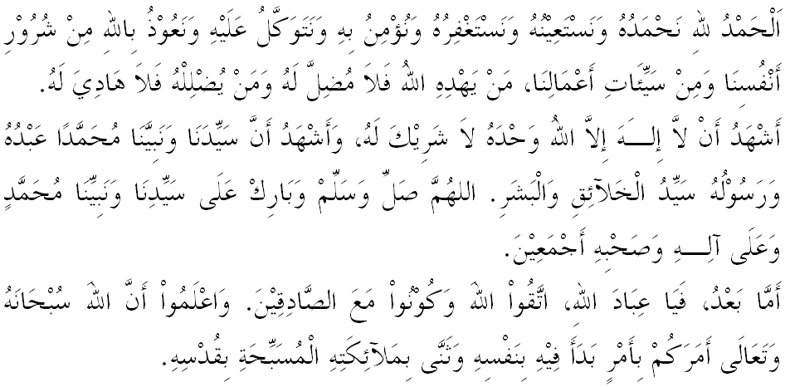
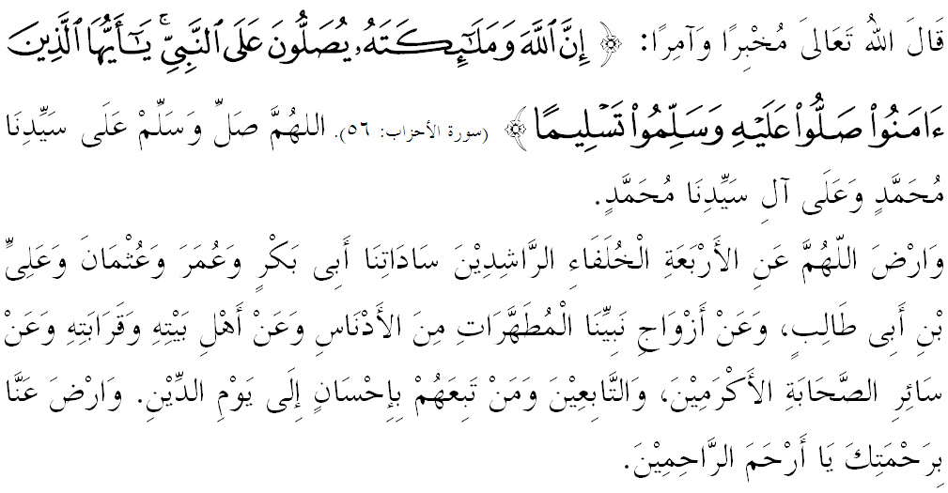

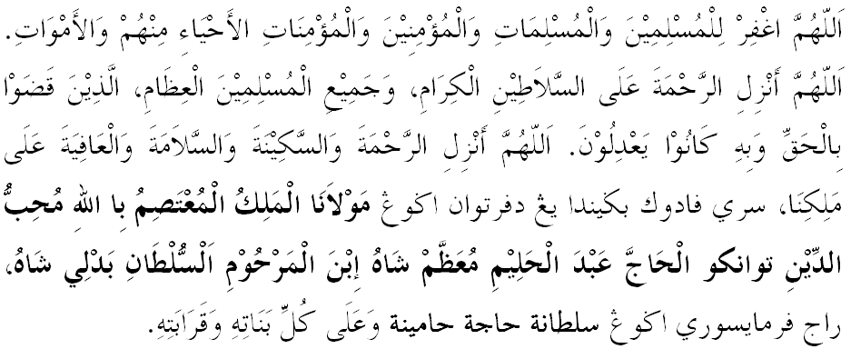
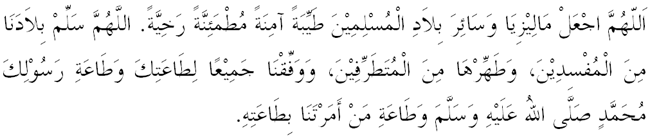

Ya Allah, we begged for Thy mercy and protection, our country and its entire people to remain in peace and prosperity. Instill a sense of affection between us. Preserve the unity among us, we wish to always live in peace, prosper and secure of all time.
