‘EID UL ADHA - SPECIAL KHUTBAH

“THE SACRIFICE OF KHALILULLAH”
(12th September, 2016 / 10th Zulhijjah, 1437)

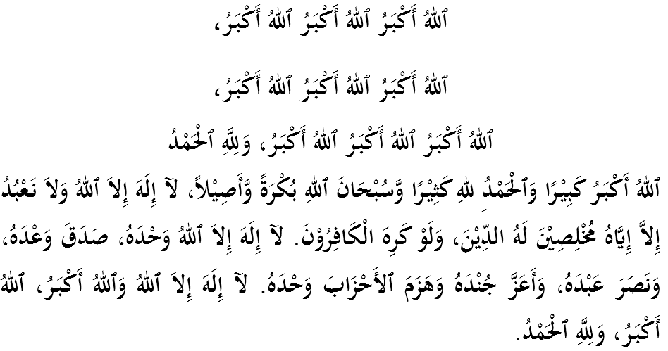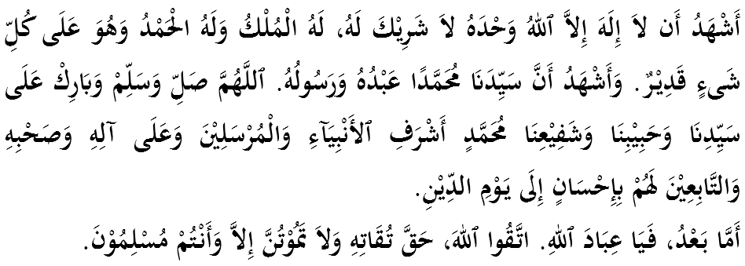

FELLOW CONGREGANTS, MUSLIMIN AND MUSLIMAT, MAY ALLAH’s BLESSINGS BE ON US,

First of all I would like to remind myself and call upon fellow congregation, le tus together strengthen our faith to Allah SWT, vigorously implement all His commandments and leave all His prohibitions. Hopefully we get His blessing and protection in this world and the world hereafter. Mimbar today will deliver a sermon titled: “THE SACRIFICE OF KHALILULLAH”.

MUSLIMIN AND MUSLIMAT,
Today is a great day grace of Allah SWT to the Muslims. Eid ul Adha is taken with the words ‘Udhiyah’ which means sacrifice. It is also referred to as Yaumun Nahar which means the day where qurban is implemented. No doubt that he presence of Eid ul Adha is highly anticipated for Muslims who really appreciate and know the rewards are great. Words of the Prophet SAW narrated by Bukhari and Muslim from al-Bara’ bin ‘Azib RA:
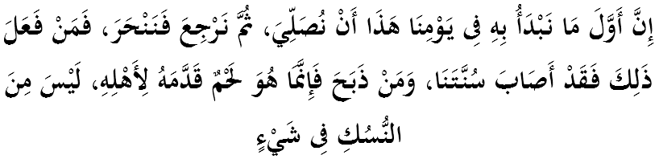
Which means: “The Prophet (p.b.u.h) said, "The first thing that we should do on this day of ours is to pray and then return to slaughter the sacrifice. So anyone who does so, he acted according to our Sunna (tradition), and whoever slaughtered the sacrifice before the prayer, it was just meat which he presented to his family and would not be considered as Nusuk."”.

At this time, there are millions of Muslims in the holy city to complete the 5th pillar of Islam, and nevertheless, there are also some of us who take advantage of this once-in-a-year opportunity to perform a ritual sunat muakkad (most sought) which is qurban (sacrifice). Qurban is not only a tradition of the Prophet SAW but even earlier prophets since Prophet Adam AS. Qurban syaria was required the first time to the children of Prophet Adam AS; Habil and Qabil, as a test for them. This syaria is also associated with a major test for the Prophet Ibrahim AS to sacrifice his own son, Prophet Ismail AS. Actually, qurban performed by Prophet Ibrahim AS and Prophet Ismail AS has brought so much teachings and lessons to us as Muslims.
Qurban is not a form of worship that is personal in fitrah but involving religious institutions which support the entire family. When Prophet Ibrahim AS dreamed about Allah’s commands him to sacrifice Prophet Ismail AS, the first thing he did was ask his wife’s opinion, Saiyidatina Hajar. This question is not intended to get her approval first before carrying out the commands of Allah, but to insist that this is the commandment of Allah SWT that can not be denied by anyone. Then answered by Saiyidatina Hajar, “If it is a decree of Allah SWT, the deliver it.” In fact, this is not the first time Saiyidatina Hajar gives answers like this. The same answer was given by Saiyidatina Hajar when she and the young Prophet Ismail AS were left in Mecca by Prophet Ibrahim AS upon Allah’s command.
The reply received by Prophet Ibrahim AS was enough to please him. His wife and child have a strong commitment to carry out the commands of Allah SWT. This is the proof that the qurban is an ibadah that must have the support and involvement of every member of the family who seriously devote themselves to Allah SWT.

MUSLIMIN AND MUSLIMAT,
Qurban teaches us that the commandments of Allah SWT are above all else. When the command of Allah SWT arrives, then everything else is small. Among the test Prophet Ibrahim AS faced before receiving the instructions of Allah SWT to slaughter his own son, Prophet Ismail AS, is to be blessed with a child so long after getting married with Saiyidatina Hajar. He was very patient and never give up praying until finally blessed with a son when he was old and some history mentions when he was at the age of 90.
When the Prophet Ismail AS reached the age of about 10 years old, his deep affection towards his son was highly built and the child was hoped to inherit his da’wah mission. However, at that time, he was ordered to sacrifice his son. Just imagine the feeling of sadness and grief that had to be borne by Prophet Ibrahim AS. Prior to that, he was ordered by Allah SWT to leave Saiyidatina Hajar and the young Prophet Ismail AS in the wilderness of Mecca. But once again, the order of Allah SWT is above all else. All feelings of sadness and grief must be set aside for the sake of realizing the obedience to the commands of Allah SWT. Prophet Ibrahim AS’s obedience was unbeatable until he was called ‘Khalilullah’ (friend of Allah). Allah SWT says in Surah an-Nisa’verse 125;
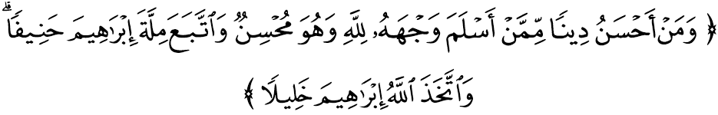
Which means: “And who could be of better religion than the man who surrenders his whole being to Allah while he does what is good, and follows the faith of Ibrahim the upright (firm and constant on monotheism), whom Allah Himself chose to be His friend?”

MUSLIMIN AND MUSLIMAT,
Qurban teaches us that in order for us to obey the commands of Allah SWT, we not only have to battle with ourselves (lust/nafs) but even incitement must also contend with iblis laknatullah. On the way to execute qurban command, prophet Ibrahim AS was seduced by the iblis several times to reconsider his actions. But whenever instigated, Prophet Ibrahim AS threw stones at them. After each throw, the faith of Prophet Ibrahim AS is increasing. The sunnah of Prophet Ibrahim AS was captured in the rituals of the pilgrimage as a practice or rule of stoning the iblis. It’s a reminder to us that when someone wants to sacrifice for the sake of Allah SWT, then surely iblis would sneak in and whisper words of persuasion to make him cancel his earlier intention to make sacrifices. It is one sunnatullah that will be faced by each of us. Thus, we were taught to deal with iblis by ’throwing’ the feelings of doubt and make a decision and determination to carry out the commands of Allah SWT.
Qurban taught us to believe that despite the wisdom and grace of Allah SWT, there are great hikmah (lessons) and nikmat (blessings) hidden because Allah SWT will never negate the practice of His servants. It was narrated that when the knife held by Prophet Ibrahim AS had already reached Prophet Ismail AS’s neck, Allah SWT has replaced him with a qibas. Then Allah SWT praise and pray for Prophet Ibrahim AS and blessed him with the second son, Prophet Ishak AS. This is a boon for people who believe in Allah SWT’s command.
Qurban test our willingness to sacrifice for the sake of raising a little treasure and uphold the syaria of Allah SWT. It is also a form of exercise to produce ‘commando’ attitude; urgently and always prepared to carry out Allah’s command in any situation. Habitually doing the qurban, we indirectly trained ourselves to sacrifice and respond to hasten Allah SWT’s commands to uphold His religion and syaria on this earth. Hopefully with consistent exercise like this, we will not feel heavy carrying out the sacrifice when receiving the call.
Clearly there are various wisdoms why qurban is calssified as sunat muakkad; most demanded. In fact, for some mazhab such as mazhab maliki, qurban is obligatory. Imam Malik mentioned in Kitab Muwatta’: “I do not like someone who is able to slaughter (sacrifice) but then he left.”
Therefore, starting this year and for years thereafter, let us together make resolutions and resolve to give encouragement to the whole family to give the best efforts to celebrate and carry out qurban. Let us all support this Sunnah as Prophet Ibrahim AS and his family embraced it. Train your children to save and determined to perform qurban. If our children are able to save his pocket money to buy a smartphone or a computer game, there is no reason why they cannot save money for the ibadah that is very meaningful.

MUSLIMIN AND MUSLIMAT,
In accordance with the theme of tests and sacrifices, khatib would like to remind all of us the great demand for us to defend the fate of the oppressed Muslims today. In the atmosphere of the Muslim world bombarded with various tribulations and tests from Allah SWT lately, sacrifice is the main source of power for these people. As our country celebrates her 60th years of independence, the Palestinians are still awaiting for the moment to be freed from the shackles of colonialism. They are bombarded with all sorts of tyranny and oppression in their homeland. The majority were forced to run for shelter in refugee camps in Lebanon, Syria and Jordan. Almost 7 million Palestinian refugees are still waiting for the time they can get back to their hometowns. They still hold the keys to their homes until today. Their health is also affected due to limited supply of food, including medicine and clean water.
Muslims in Syria are also faced with terrible destruction and death. The situation worsened with the emergence of extremist groups DAESH or ISIS (Khawarij group in modern times) who were not only hostile to Syiah, but also killing the Sunni who disagree with their approach and did not give bai’ah to them.
In addition, we also feel compelled by the fate of Muslims in countries such as Myanmar, Iraq, Yemen, Sudan, Libya, Xinjiang, Cambodia, Vietnam, Mindanao, Sri Lanka and Nepal, which is stucked in oppression, under-development and poverty. They also need to get the attention of us all on this Eidul Adha in our efforts to live up to the meaning of the sacrifices to preserve the safety and dignity of Muslims, religion and country.
Thus, khatib would like to congratulate the people of Malaysia who are very concern, which has not only seized the blessings of Eid ul Adha but has moved to implement qurban overseas, particularly in the countries of the Muslims who need defense as khatib described just now. Indeed, this practice is a form of jihad must continue and be eligible for a reward that is promised by Allah SWT. Allah SWT says in Surah as-Saff, verse 10-11:
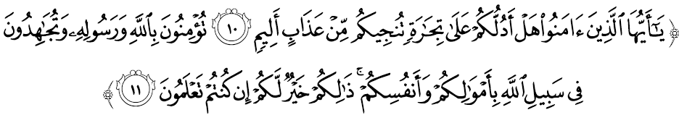 Which means: “O believers! Shall I point to you a bargain that will save you from a painful torment? That is, you believe in Allah and His Messenger and you strive to defend and uphold the religion of Allah with your wealth and your persons. That would be best for you, if you but knew (the truth).”

MUSLIMIN AND MUSLIMAT,
Ending the sermon today, let us internalize the essence of the sermon that has been delivered just now:
First: | The sacrifice of Prophet Ibrahim AS and his son, Prophet Ismail AS must be appreciated to express our obedience to Allah unequivocally.
Second: | The noble nature of Prophet Ibrahim AS precede the commands of Allah SWT above everything else proved that the love of the hereafter should be more than the love of wealth.
Third: | Qurban practice should be applied in every Muslim to educate people to infaq their property on Allah SWt’s path without any hesitation in helping Muslim brothers and sisters along with constant prayers and financial contributions.
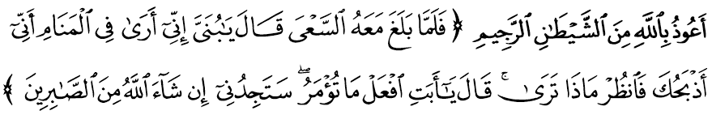 Which means: “When the son reached (the age when he could) work, Prophet Ibrahim said: ?O the apple of my eye! I dreamt that I was sacrificing you. Tell me what you think?? His son replied: ?Father! Do as you are bidden; Allah willing you shall find me one of those who are steadfast?”. (Surah as-Saaffaat: 102)

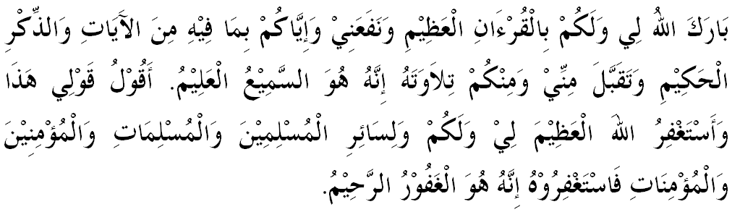
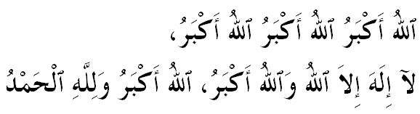

“ SECOND KHUTBAH”

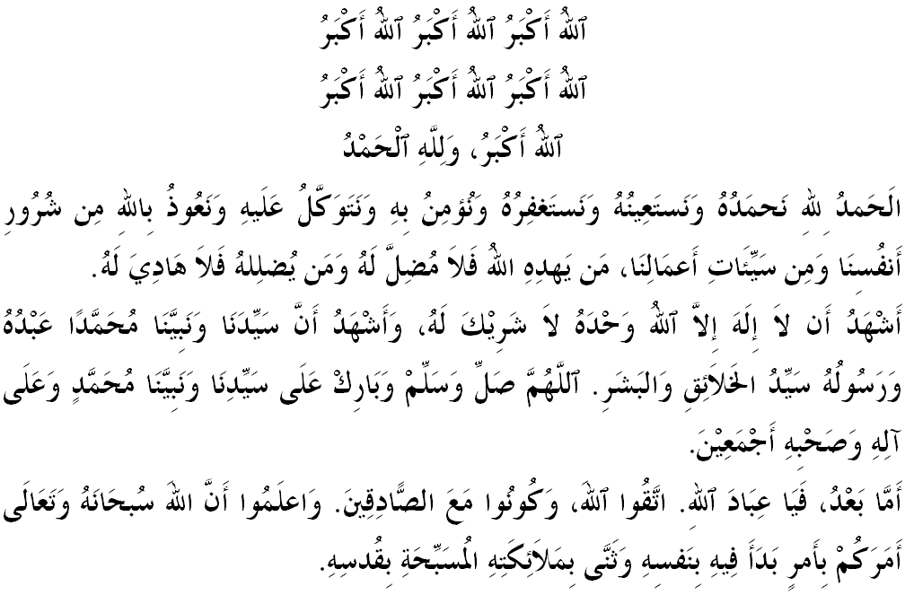
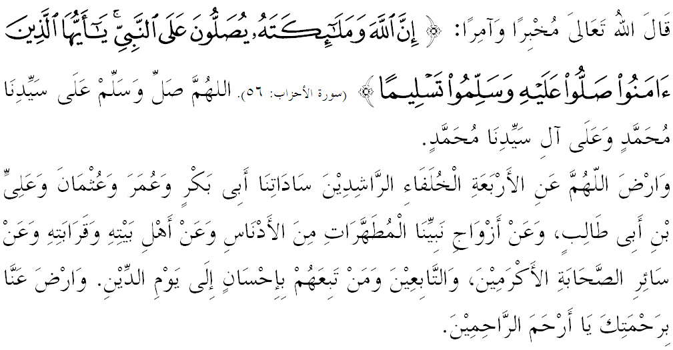
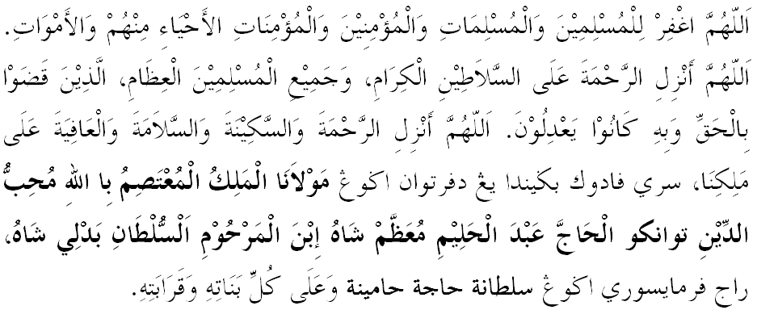
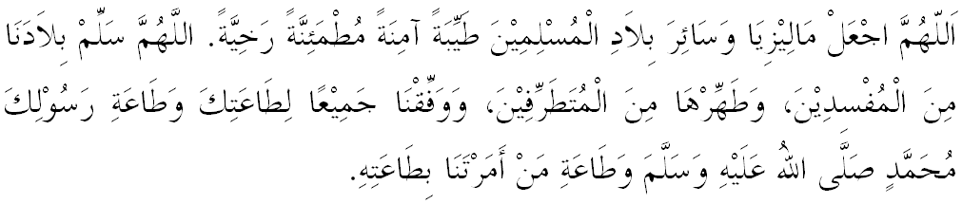

Ya Allah, we begged for mercy and Thy protection, our country and its entire people to remain in peace and prosperity. Instill a sense of affection between us. Preserve the unity among us. We wish to always live in peace, prosper and secure of all time.
