


“UKHUWAH ISLAMIAH:

THE BASIC OF UMMAH SOLIDARITY”
(30 September 2016 / 28 Zulhijjah 1437)

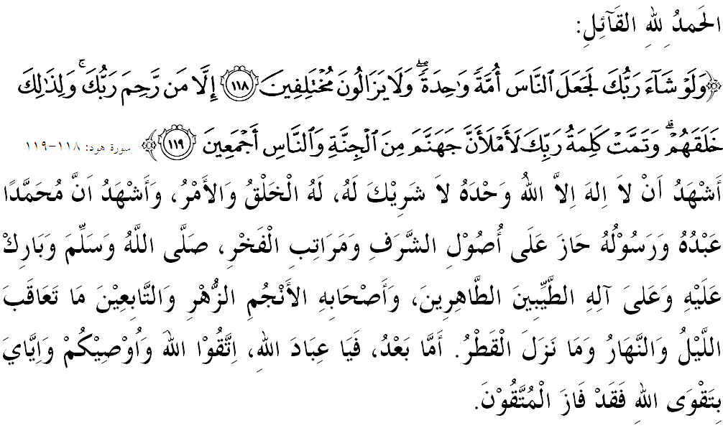

FELLOW CONGREGANTS, MUSLIMIN AND MUSLIMAT, MAY ALLAH’S BLESSING BE ON US,

I call myself and my dear brothers, let us together strengthen our devotion to Allah SWT by doing all His commands and leave all His prohibitions. Hopefully, we will be blessed with happiness in this world and victory in the hereafter. Mimbar would like to invite in the hereafter. Mimbar would like to invite everyone to appreciate today’s sermon entitled: “UKHUWAH ISLAMIAH: THE BASIC OF UMMAH SOLIDARITY”.
MUSLIMIN AND MUSLIMAT,
Celebrating Maal Hijrah each year, we often hear when a specific theme is being read and studied, implied a great message of the importance of community in the country to live united, mutual respect and mutual help to each other. Natuarally, we cannot deny that the root of a strong brotherhood among the Muslim community is capable of generating success and excellence to the welfare state. Therefore, the brotherhood of Islam is a very important element in uniting the community to ensure harmony, independence and sovereignity of the country remains.
The question is how we can strengthen the bonds of brotherhood? Yes, Islam has laid the foundations of a practical and positive way in strengthening the bonds of affection and deepens the spirit of brotherhood. If Muslims adhere to each other, it would strengthen the brotherhood in a way where they reinforce each other in harmony and friendly, although hampered by many challenges trying to thwart progress and raise issues of discord among Muslims. It has been recorded throught the word of Allah SWT in Surah al-Hujurat verse 10:
Which means: “Truly the believers are brothers. Make peace among your brothers (who are fighting); and remain conscious of Allah, so that you may be shown mercy”.

MUSLIMIN AND MUSLIMAT,
Despite all the principles and values of Islam remain clear and even believed to be quite perfect, we must realize that we cannot restore the position and strength to build and develop civilization, religion, race and nation had split and slander are still rampant. Allah SWT reminds us in verse 46 of Surah al-Anfal:

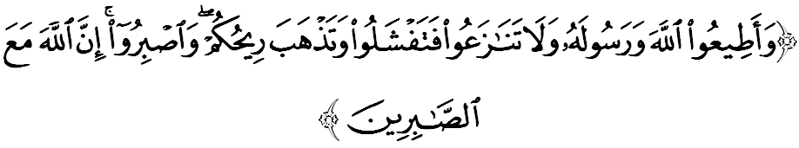
Which means: “And obey Allah and His Messenger, and do not dispute among yourselves, lest you lose cpurage and your strength will depart from you. And be patient in adversity: Allah is with those who are patient in adversity”.

Indeed, the most important thing to focus on is to practice the methodology or approach that is balanced (wasatiyah)) because Islam is a religion that is based on balance and tolerance. However reformation cannot be achieved if there is hatred, jealousy and hostility. Also the capacity to love, good manners, tolerance and think well of others is a guarantee of faith in Allah SWT in creating good and stable society and a prosperous country.

MUSLIMIN AND MUSLIMAT,
Know that the dispute between humans is sunnatullah. However, uslub discussions that are carried out with wisdom, gentle, friendly, and clear mind are greatly needed to get consensus and blessings. All Muslims must know that strengthening the family ties is jihad that brings consolidation, rather than split. Thus, we are able to defeat all the enemies, especially enemies within us which are the desire and the temptations of Satan. In addition, we should also stay away from the paths that can lead to extremism, fanaticism, fragmented, immoral and such. This coincided with the words of the Prophet SAW, which is:
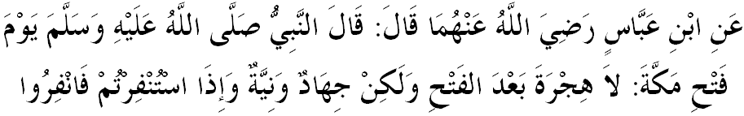

Which means: “Narrated by Ibn `Abbas RHMA, the Prophet (ﷺ) said, on the day of the Conquest of Mecca, "There is no migration (after the Conquest), but Jihad and good intentions, and when you are called for Jihad, you should immediately respond to the call.” (Sahih al-Bukhari)

Eventually, hijrah have taught us the meaning of solidarity a lot. Just look at how the success of the Prophet SAW in uniting Aus and Khazraj which were once a rival, in the name of brotherhood and love for the sake of Allah SWT. Therefore, Islam strictly prohibits any form of oppression, injustice, cruelty or hostility because Islam is a religion of mercy to the entire world.

MUSLIMIN AND MUSLIMAT,
If viewed from the era of globalization, hijrah covers changes and migration of various aspects of the physical, mental, attitude, heart, in addition to the environment and so on. These changes can alter the living conditions both in terms of economic, social, education and standard of living. Now, our country has undergone many changes and achievements from one stage to another stage, better and brighter. What is sure is that the blessings and prosperity are given and can also be used for the benefit of living in this world and in the hereafter.

Knowing it or not, Muslims are composed of two groups that are strong, strengthen each other like the Ansar (helpers) and Muhajirin (assisted), grew into an Islamic society named as ummah Islamiyah which became much stronger and able to defend themselves if they can end any hostilities with the spirit of brotherhood agenda of Ukhwah Islamiah.

Therefore, mimbar urge the congregation, let us return to the true teachings of Islam so that we become moreclosely united and strong, hence enemies will not dare to tear us apart as they please. Hijrah managed to redeem the oppressed people free, an individual who’s being insulted become noble, and weak people become stronger.

MUSLIMIN AND MUSLIMAT,
In conjuction with the National Maal Hijrah 1438H Celebration on October 2nd, 2016 at Malaysian Agriculture Exposition Park Serdang (MAEPS), mimbar would like to invite the congregation, let us continue to strengthen the relationship among us and upholding the government’s efforts in maintaining unity, peace and harmony with full mahabbah to transform the country’s prosperity as proof of the solidarity of the ummah in the country in promoting security, regardless of political affiliation.

Ending the sermon today, mimbar Friday would like to invite the congregation to appreciate the essence of the sermon as guidance in our lives, including:

First : | Hijrah is the symbolic of where the spirit of Islamic brotherhood (ukhwah Islamiyah) sprouts and instilled in Muslims so as to resolve any disputes among themselves.
Second : | Hijrah injects the success of united life to form a strong hold so that it can solve all the problems based on Islamic faith.
Third : | Empowering Islam through jihad field of knowledge, economyand development of ummah is a very practical example for settling the spirit of hijrah in a wider meaning.
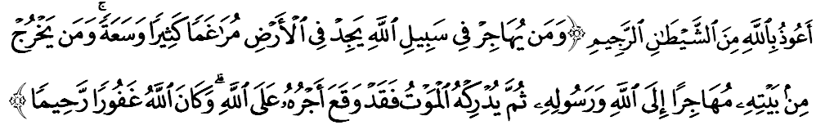Which means: “And he who migrates for the cause of Allah (to uphold Islam) shall find numerous places of refuge on earth and great abundance. And he who leaves his dwelling to migrate in the cause of Allah and His Messenger, and is then overtaken by death (in his journey in migration), his reward is certainly incumbent on Allah. And (remember that) Allah is Most Forgiving, Most Merciful.” (Surah an-Nisa’ verse 100)

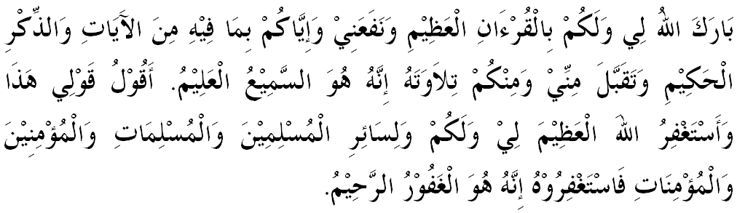



“SECOND KHUTBAH”

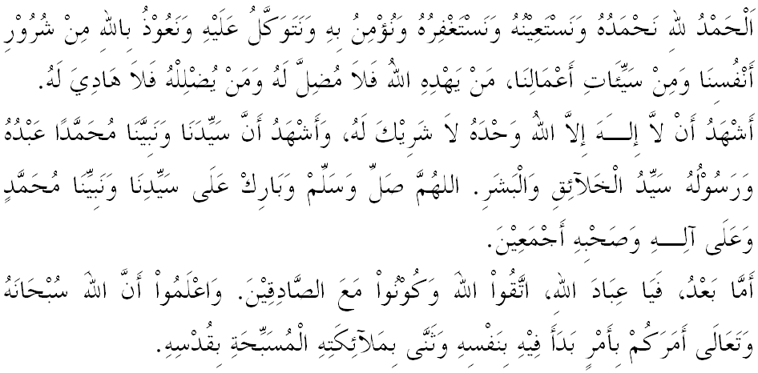
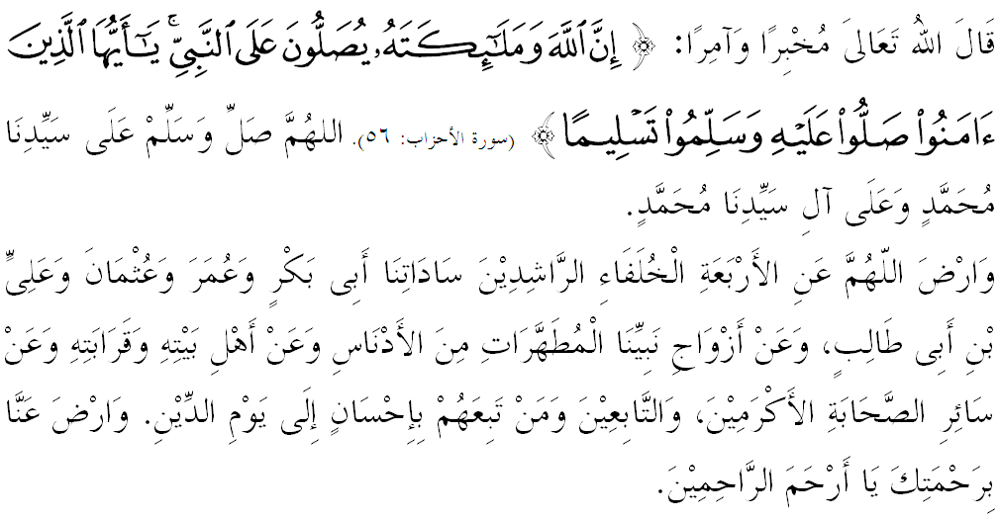

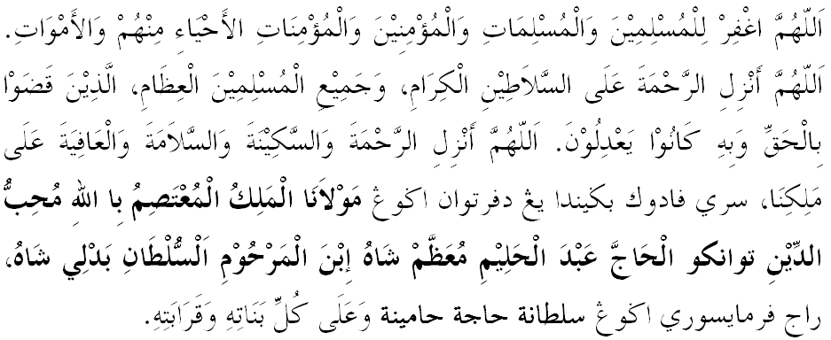
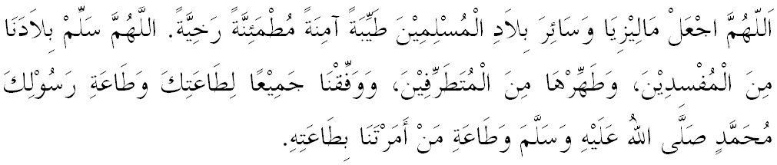

Ya Allah, we begged for Thy mercy and protection, our country and its entire people to remain in peace and prosperity. Instill a sense of affection between us. Preserve the unity among us. We wish to always live in peace, prosper and secure of all time.
