Department of Islamic Development, Malaysia
“THE DANGER OF RELIGIOUS EXTREMISTS"
(27 FEBRUARI 2015 / 8 JAMADILAWWAL 1436)
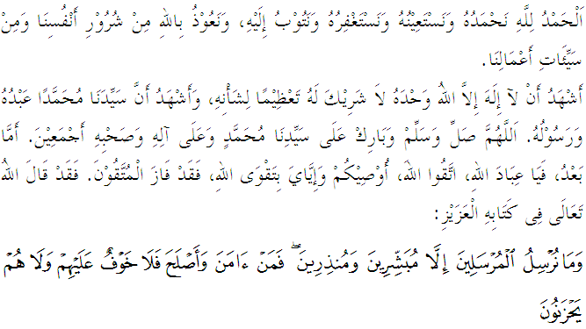
Muslimin, May Allah’s blessings be on us,

On this blessed Friday and in the holy mosque, let us together to increase devotion to Allah SWT by vigorously implementing all his commandments and abstaining from all His prohibitions, surely the most honorable in the sight of Allah SWT is the most pious person. The title of the Khutbah today is "The Danger of Religious Extremists".
Muslimin, May Allah’s blessings be on us,
The noble Mimbar today called on the congregation and all Muslims to let us build a community that love their religion, race and country and together maintain the peace and prosperity we enjoy today. Even people in our country are from different races and religions but each of us must be responsible and always ready and willing to sacrifice self-interest for the sake of religion and the country that we love. Mimbar would like to emphasize one of the most important aspects that contribute to this situation is to uphold the peace. Allah SWT says in Surah an-Nahl verse 112:
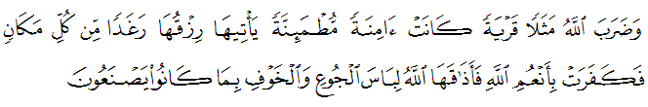
Interpreted to mean: “And (regarding the unbelievers) Allah has made a parable about a city which was once safe and peaceful. Its provisions used to come in abundance from every quarter, but its people denied the favours of Allah. Therefore, Allah made it taste of hunger and fear closing on it on every side like a garment because of the evil which the people had been doing.”.
Be assured that peace is a very important thing in human life, whether at the individual level or society for the betterment of humanity. In the history of human civilization itself has shown the peace impact for global prosperity. Peace means that we are free from danger, free from crime, accidents, and others. These include peace aspects of nationhood, family, socio-economic and so on.
Thus, Islam balked all movements that threaten the peaceful in any forms including those brought by religious extremists. The threat of religious extremism should be considered by all parties because it involves issues of public security. If this is not met, then the country will fall and be in chaos. As a democratic country which practises tolerant lifestyle to different views on religion, culture, race, politics, ideology, and others. But at the same time, citizens have no right to be extremist in their beliefs that lead to acts of violence to force others to accept it. Remember the message of the Prophet Muhammad SAW in a hadith narrated by Ibn Abbas RA that the Messenger of Allah said which means: Be careful with religious extremists. The ancients had vanished, withdrew due to religious extremism. And the Prophet SAW also said, which means: Do not too troubled yourself. Surely people before you fell on destruction because of their extreme attitude and troubled themselves. Their remnants are still to be found in places of worship (Narrated by at-Tabari). According to Prof Dr Abdul Muin Salim in his book Fiqh al-Siasah, he explained that: Creating an unstable atmosphere in a peaceful country is illegal. Deliberately creating an atmosphere inviting to most destabilized further harm to the public is haraam.
Muslimin, May Allah’s blessings be on us,
The issue is why there are still a few people who adhere to the principle of this religious extremism ? According to Prof Dr Yusuf al-Qaradawi in his book dangers of religious extremism stated several reasons why they are considered as extreme are, first: obsessed and too rigid with a certain opinion, Second: Like to do work hard and force others to do so, third: extreme at the wrong place, fourth: harsh and violent, fifth: bad thoughts to others and sixth: a tendency to claim others as disbelievers. Therefore, as Muslims who believe we should reject all the reasons causing this extremism that can threaten the safety and security of the country. Be assured, that all forms of struggle to maintain peace and security is part of our worship in the way of Allah SWT. We must realize and remember in our heart and soul, we should protect and maintain the peace that we have today, because it is too valuable where our brothers in other countries are longing for it. This is the time, all the Muslims in the country must be united by all existing capabilities and to reject any attempt of any party that tried to destroy the peaceful of this country. Allah SWT says in Surah al-Anaam verse 82:
Interpreted to mean: “Those who have attained to faith and have not obscured their belief with wrongdoing (by polytheism) - it is they who shall be secure, since it is they who are on the right path. ”.

Muslimin, May Allah’s blessings be on us,
According to history, our country has been faced with a series of security threats, starting with communist terrorists during an emergency and the emergence of several militant groups such as sabilillah military group, Nasir Ismail group, al Maunah and more, all demanding the war and bloodshed and soul. Today once again we were shocked by the state of security threats that movement Daulah Islamiyah militant group or known as the Islamic State (IS). This group tries to spread its influence to recruit, especially the young children to join the jihad policy. According to reports received, the spread of IS influence in our country is widely seen mainly through social media such as facebook, Instagram, Youtube and Twitter to get the support.
Observation shows that a small number of people in this country are interested to go to Syria and Iraq on the basis of jihad and the desire for martyrdom. They kill anyone regardless Muslims or non-Muslims, they also legalize more aggressive action and destruction of property even involving the rights of their own brothers and sisters. Therefore, as Muslims, we should resist all attempts to spread the movement of this group. Believe that the movement of IS group is contrary to the principles of Ahlu Sunnah waljamaah and teachings of Islam and true principles of jihad. Allah SWT has given this reminder as Allah says in Surah Ali Imran verse 142:
Interpreted to mean: “Did you suppose that you would enter Paradise before Allah has known the men who fought hard and those who were steadfast (persevering in their struggle)? .

Muslimin, May Allah’s blessings be on us,
Mimbar wants to emphasize, we must not become a Muslim who bring defamation of Islam itself. Let us not misinterpret the meaning of jihad that will cause Muslims to be seen in the eyes of the world as the people of extremism and terrorism. What is certain is that Islam is indeed a religion rejects all forms of violence and war but geared towards peace and universality of mankind as a whole. However, the effect of the actions of religious extremists who commit violent series generated a lot of destructions to mankind causes the image of Islam is getting scratched. In fact, Muslims must find ways and introduce Islam to non-Muslims as well as introducing a system of Islam as a religion of peace and not of war.
As Muslims, we should increase the Islamic brotherhood and remember that the history of the country's prosperity is based on peace and tolerance among us. Let us strengthen our love to Allah SWT with a sincere struggle for the religion of Allah, Allah's laws and increase the good deeds so that we continue to fight for the sake of Allah SWT and fi-sabilillah. Ending the Khutbah this week, let us reflect the word of Allah in Surah al-Baqarah verse 190:
Interpreted to mean: “And fight for the sake of (establishing and protecting the religion of) Allah those who fight against you, but do not commit aggression (by initiating the fight), for Allah does not love the aggressors.”

