
IDUL ADHA 1436H
“SACRIFICE ANYTHING”
(24 September 2015 / 10 Zulhijjah 1436H)
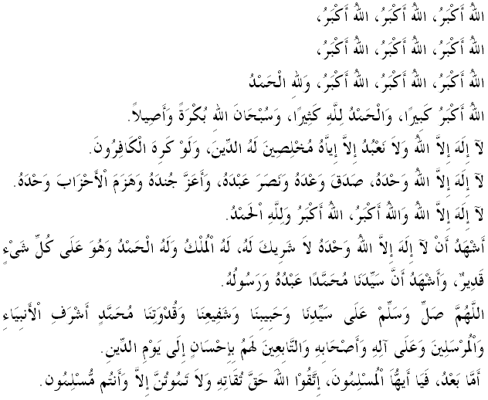

FELLOW CONGREGANTS, MUSLIMIN AND MUSLIMAT, MAY ALLAH'S BLESSINGS BE ON US,
I remind myself and gentlemen, let us intensify our gratitude and devotion to Allah SWT with true piety, by performing all His commandments and leaving His prohibitions. With Allah's willing, hopefully we succeed in life in this world and the hereafter. The mimbar of IdulAdha today will deliver a Khutbah entitled "SACRIFICE ANYTHING".
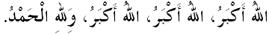
MUSLIMIN AND MUSLIMAT,
All Muslims in Malaysia are very much welcoming the celebration of IdulAdha. Also, on this day, millions of Muslims including Malaysians are gathering in the city of holy Mecca to perform the Hajj. For those of us who did not had the opportunity to be the guests of Allah SWT to the Holy Land of Mecca at this time, today we gather, chant takbir, tahlil, tahmid, tasbih and perform IdulAdha prayer. Besides, on this day onwards, Muslims are commanded to perform the highly encouraged qurbani for the flesh to be given to the needy people solely because of Allah SWT. Narrated Al-Barra bin ‘Azib (RA): The Prophet Muhammad SAW said:
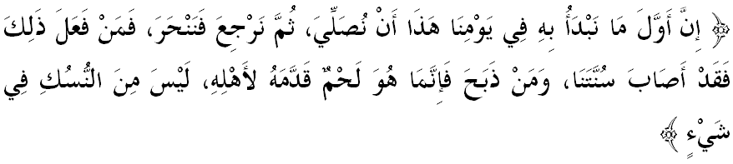
“The first thing that we should do on this day of ours is to pray and then return to slaughter the sacrifice. So anyone who does so, he acted according to our Sunna (tradition), and whoever slaughtered the sacrifice before the prayer, it was just meat which he presented to his family and would not be considered as Nusuk.”
(Found in Bukhari and Muslim)

FELLOW CONGREGANTS, MUSLIMIN AND MUSLIMAT, MAY ALLAH'S BLESSINGS BE ON US,
Let us reflect for a moment the history of Prophet Ibrahim a.s. as a messenger, known as Khalilullah, which has always been close to his heart and always wants to be closer to Allah SWT. He has been tested with various tests from Allah SWT, but all of them are passed with high patient and persevere for the sake of love and taqwa to Allah SWT. He was willing to sacrifice anything for the sake of devotion to Allah SWT.
At his young age, he has been raging conflict between his sacred spiritual thoughts and the situation surrounding his community at that time where they worshiped idols. Prophet Ibrahim a.s. cannot take it anymore and destructed and destroyed all the idols including his father's idol.
Due to these actions, he was set on fire by King Namrud in rising flames. However, with Allah's permission and will, he survived without the slightest injury. This is the proof of obedience and devotion to his Khaliq (Creator). He was confident and had faith with Allah's power and majesty, hence willing to sacrifice one's life for the love of Allah SWT.
In fact, his biggest test was received when he was commanded to sacrifice his beloved son Ismail a.s. that he has been praying and waiting for so long. However, due to his obedience and devotion to Allah SWT, he admitted. Therefore, Muslims today should learn from the sacrifice of Prophet Ibrahim and his willingness to sacrifice anything for his faith, loyal and obedient to the commands of Allah SWT.
ُ
MUSLIMIN AND MUSLIMAT,
IdulAdha, known as the Day of Qurbani also refers to the demand of sacrifice that is needed to be implemented by Muslims. The combination of history and the demand to perform the sacrifice on IdulAdha can affect the spiritual greatly and deep appreciation towards one's soul.
What is the use of wonderful sacrification history of the Prophet Ibrahim a.s. and his son Ismail like every year we talk about, if we had been cold to the performance of ritual slaughter organized while we can actually afford it? What is the point of feeling proud of the great sacrifice of the Prophet Muhammad s.a.w and his companions, if we just stood by and watched without extending any contribution to develop Islam? Supposedly these beautiful stories are able to capture our hearts and souls to even sacrifice some of property for the sake of proving our faith by performing the sacrifice as prescribed by the syariah.
MUSLIMIN AND MUSLIMAT,
Are stories about sacrifice and struggle has ended with the death of the Prophet Muhammad s.a.w. and his companions? This is because the struggle for Allah's religion will never stop as long as it is not the end. The struggle to uphold the religion of Allah is a way of sacrifice for the sake of pure humanity. Islam is the only way for us to reach mardhatillah as described in the word of Allah SWT in Surah Ali Imran verse 19:
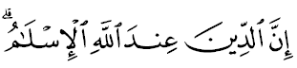
“Surely (the only true), faith in Allah’s sight is Islam”

MUSLIMIN AND MUSLIMAT,
Thanks to Allah SWT for the great privilege given today, in addition to the celebration of IdulAdha for us in our beloved motherland. Today is a beautiful day for some of our brothers who have completed the implementation of pilgrimage in the Holy Land of Mecca. May all the sacrifices and hardships they went through during the pilgrimage are rewarded by Allah SWT with "Haji Mabrur".
Let us pray that all pilgrims especially our family members who are currently doing the pilgrimage to the Holy Land of Mecca at this point be given good health, mind cleared, simplified all matters of worship there. We also pray for the victims of pilgrims and families of those affected in the crane collapsed tragedy at the Grand Mosque to be patient facing the incident. All Malaysians deepest condolences and sympathy to the family members for the tragedy. A total of 234 pilgrims were injured and 111 people were killed, including four Malaysian pilgrims who have been identified so far. Let us pray that their souls are placed among those who believe, and promised heaven by Allah SWT.
MUSLIMIN AND MUSLIMAT,
Indeed, the pilgrimage trains people to be willing to sacrifice anything just because of self devotion to Allah SWT. It is also train oneself to be patient when facing obstacles and tests, in addition to strengthening the resilience of people to strengthen the unity of Islam around the globe. Know that great rewards has been prepared for those who earnestly doing the pilgrimage and Umrah as the words of the Prophet s.a.w narrated by Abdullah bin Mas’ud:
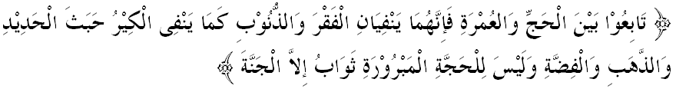“Make the Hajj and the Umrah follow each other closely, (wear the Ihram for Qiran, in which the intention of Hajj and ‘Umrah is done or perform both the Hajj and ‘Umrah consecutively) for they remove poverty and sins as a furnace removes impurities from iron, gold and silver; and Hajj which is accepted, its reward is Paradise.” (Sunan Tirmidhi)

MUSLIMIN AND MUSLIMAT,
The pilgrimage was the culmination of a servant to sacrifice his Creator as the Word of God through Surat Al Kawthar;
“Indeed, We have granted you (O Muhammad) abundance (in this world and the Hereafter). Therefore, pray to your Lord and sacrifice to Him only (as a sign of gratefulness) for he who hates you, shall be deprived (from getting what he desires).”

MUSLIMIN AND MUSLIMAT,
Ending the khutbah this week, there are several conclusions we can take lessons, namely :
First: Muslims are urged to be willing to sacrifice anything, including wealth, personal interests, even life for the sake of promoting Islam and worship Allah SWT.
Second: The level of faith and devotion to Allah SWT can be measured by the extent to which our willingness to sacrifice for the sake of obeying His commands.
Third: Perform hajj when affordable and do not delay.
Fourth: Fraternity and solidarity among the Muslims can be developed regardless of rank, wealth, skin color, race or political affiliation during the pilgrimage. This is an example of unity among the community that need to be applied at the heart of every believer.
Fifth: The Hajj is prescribed to people of Prophet Muhammad are evidence of the integrity of the faith of Muslims from around the world to Allah SWT.
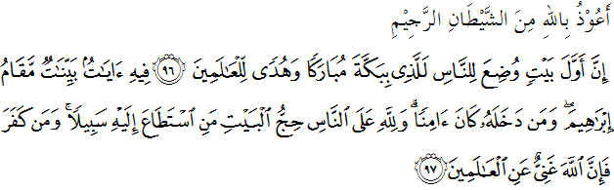“Truly, the first House (of worship) ever to be built for men was the House of Allah at Makkah, a blessed place, (made) a beacon for the nations.. In it there are Clear Signs (reflecting its sacredness. One of them is) the spot where Prophet Ibrahim stood. And whoever enters it is safe. Pilgrimage to the House is a duty owed to Allah for all who can make the journey. As for those who disbelieve, (in the obligation of pilgrimage to the House), then truly Allah does not stand in need of anything in all the worlds.”
(Surah Ali-Imran: 96-97)
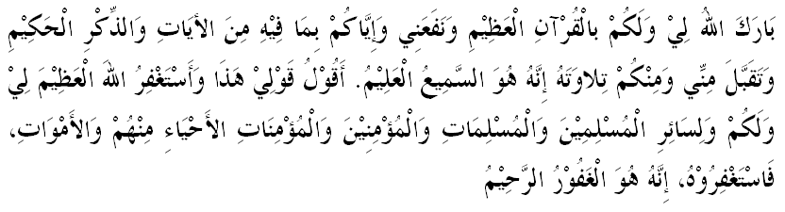

Second Khutbah
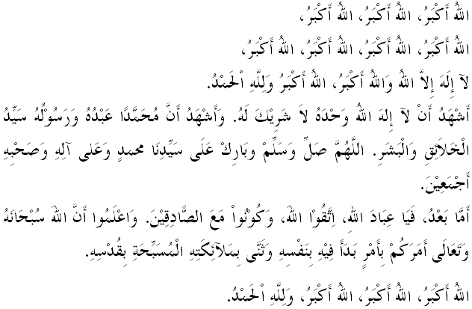MUSLIMIN AND MUSLIMAT,
On this blessed day, we express our gratitude for the blessings bestowed by Allah SWT. Indeed, all around us, there are still those who are less fortunate and need help from us. After this, Muslims will perform the ritual sacrifice to elevate syiar Islam. Animals to be sacrificed must comply with certain conditions laid down by Islam. With this, it shows that Allah SWT does not accept worship that is done half-heartedly, do not comply with the regulations and ignore the question of perfection of worship to be performed. Therefore thoroughness and seriousness in doing any work must be considered by all Muslims.
Remember that every sacrifice that we do must be accompanied by a sincere intention and practice. If we do qurbani that contaminated with riak , takabbur and show off attitude, the mercy of Allah SWT will slipped through and the practice that we do is pointless. Let there be no complaints or price comparisons among us who participated in the ritual sacrifice with the words: "Elsewhere the qurbani share is even lower in price”. Or in other words: "A share of a cow or a goat sacrifice this year is too expensive." That's where the real picture of the identity, integrity or sincerity we perform the ritual sacrifice or other religious worship, whether mandatory or voluntary. The meat should be distributed to their owners in the form of raw meat. The law of qurbani meat distribution is different from the law of distribution of the akikah meat in which it is in the cooked meat dishes.
Thus, the distribution of qurbani or aqiqah meat shall conform to the conditions for ensuring the perfect implementation of the ibadah. One section is devoted to oneself and his family as to express his gratitude to Allah SWT for the blessings of excess sustenance that able them to perform the sacrifice. The act of giving meat also will strengthen the love between the families. One part of the meat are also distributed to the poor with the desire to bring joy to those who may be carryover meat only once a year. While the other part is given to the neighbors and friends with the prayer that it may help strengthen relationships and ties. Hopefully with this, the desire to help ease the burden, improve the quality of life and foster better relationships between Muslims themselves are achieved.
Mimbar very much welcomed the efforts that have been undertaken by certain parties such as mosques, surau, NGOs and other Islamic organizations that conduct qurbani in Muslim minority countries such as Cambodia, Vietnam and Philippines. The most important thing is for those who sacrifice their wealth and livestock for the purposes of this sacred act to have total devotion and sincerity towards Allah SWT. Mimbar deeply appreciate pilgrims and all Muslims who perform qurbani either at village, township or abroad.

MUSLIMIN AND MUSLIMAT,
On this day let us increase salawat and peace be upon the Prophet Muhammad as Islam has been submitted to us through various forms of sacrifice and jihad. Sign of our love for him must be recorded in the form of salawat and salam as the words of Allah in Surah al-Ahzab verse 56:
“Truly Allah and His angles shower blessings on the Prophet (giving him honour and graces). O Believers! Bless him and greet him with a worthy salutation.”

